Azure Data Factory Contents

1. Introduction to Azure Data Factory 2

2. Major Component 2

3. Scenario 3

4. Creating Azure Data Factory 4

5. App Registration 5

5.1. Need for App Registration 5

5.2. Creating App Registration 5

5.3. App Registration Creation 6

5.3.1. Service principle ID 7

5.3.2. Generate secret key 7

5.4. Setting App registration with Data Lake Store 8

6. Linked Service 9

6.1. Need for Linked Services 9

6.2. Creating Linked Service 10

6.2.1. Creating Linked Service for On-premise SQL DB 10

6.2.2. Creating Linked Service for Azure Data Lake Store 14

7. Dataset 15

7.1. Need for Dataset 15

7.2. Creating dataset for on-premise SQL DB 15

7.3. Creating dataset for Azure Data Lake 16

8. Working with Pipeline 19

8.1. Creating Pipeline to copy the data from on-premise SQL DB 19

8.2. Executing Pipeline 21

8.3. Creating Pipeline to copy the data from Azure BLOB storage 22

9. Transforming Data Using Pipeline 28

9.1. Union Transformation 28

9.2. More Transformation 35

10. Triggers in Pipeline 44

10.1. Types of Triggers 44

10.2. Schedule Trigger 44

**Azure Data Factory**

# Introduction to Azure Data Factory

Azure Data Factory is Azure's cloud ETL service for scale-out serverless data integration and data transformation. It offers a code-free UI for intuitive authoring and single-pane-of-glass monitoring and management.

 It is the *cloud-based* ***ETL and data integration service that allows you to create data-driven workflows for orchestrating data movement and transforming data at scale***. Using Azure Data Factory, you can create and schedule data-driven workflows (called pipelines) that can ingest data from disparate data stores. You can build complex ETL processes that transform data visually with data flows or by using compute services such as Azure HDInsight Hadoop, Azure Databricks, and Azure SQL Database.

Additionally, you can publish your transformed data to data stores such as Azure Synapse Analytics for business intelligence (BI) applications to consume. Ultimately, through Azure Data Factory, raw data can be organized into meaningful data stores and data lakes for better business decisions.

# Major Component

================

- Pipeline

- Activity

- Movement

- Transform

- Control

- DataSet

- Linked Services

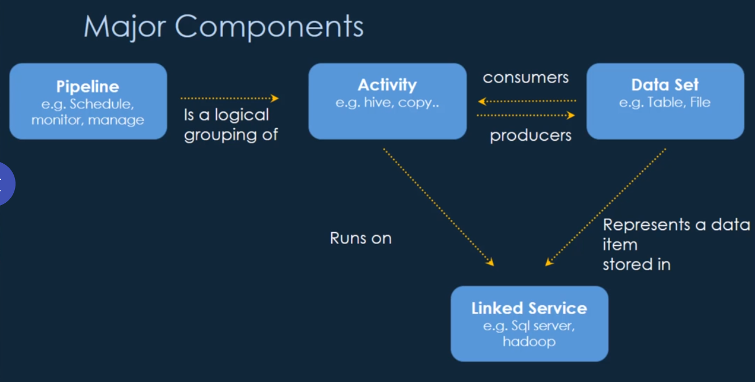

# Scenario

==================

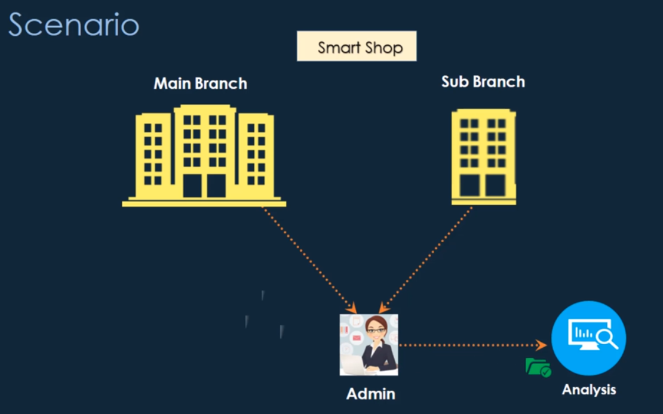

We need to automate the task

We will See

How to create an Azure Data Factory

What is a need of linked services and its creation?

The need for dataset and its creation

How to create a pipeline and add the activity to copy the data

How to transform the data

How to schedule the trigger to execute the pipeline

# Creating Azure Data Factory

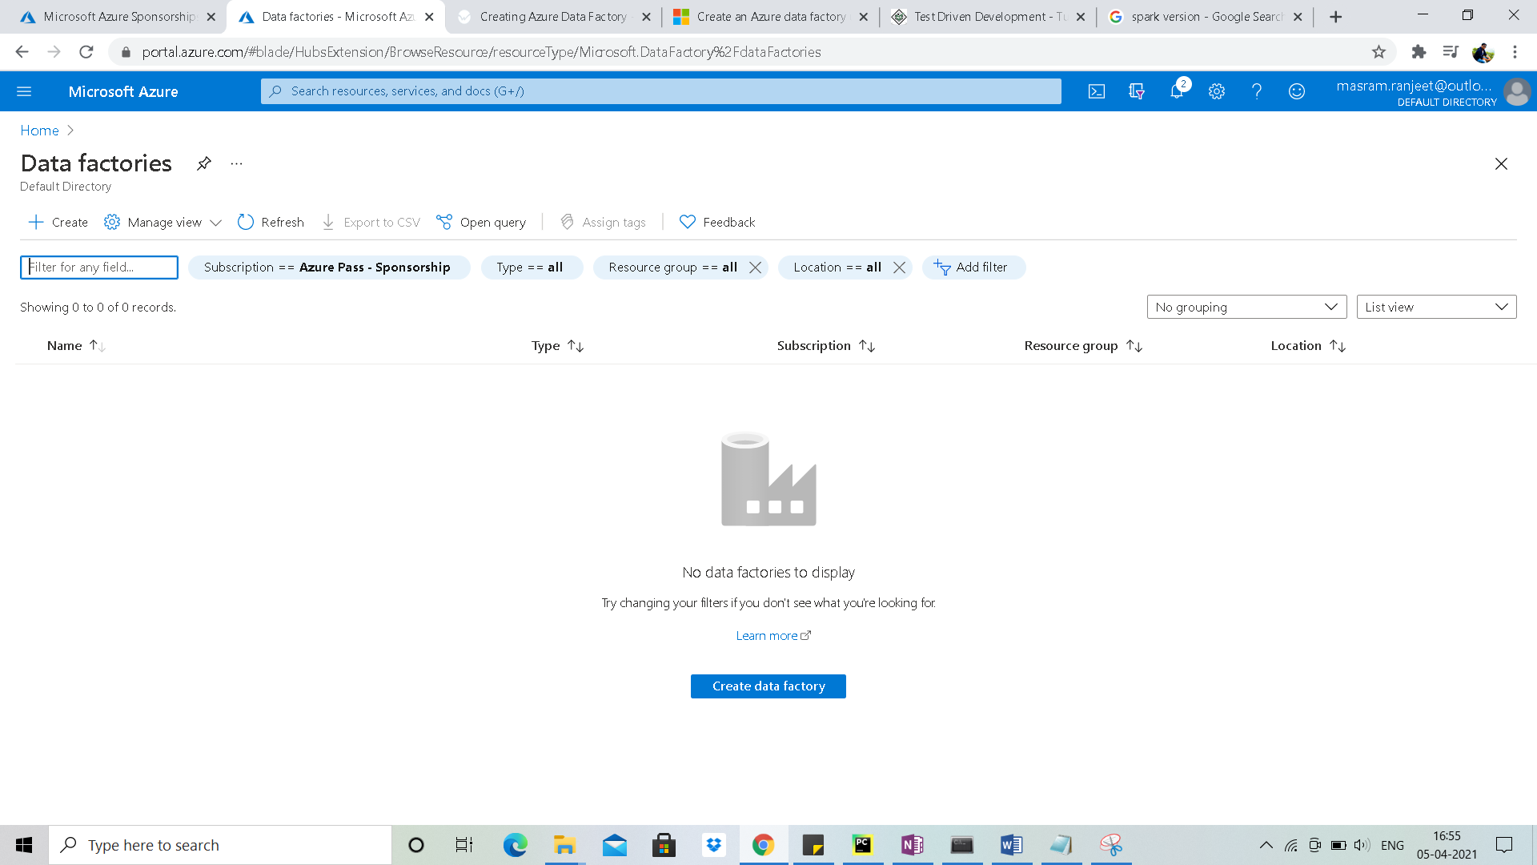

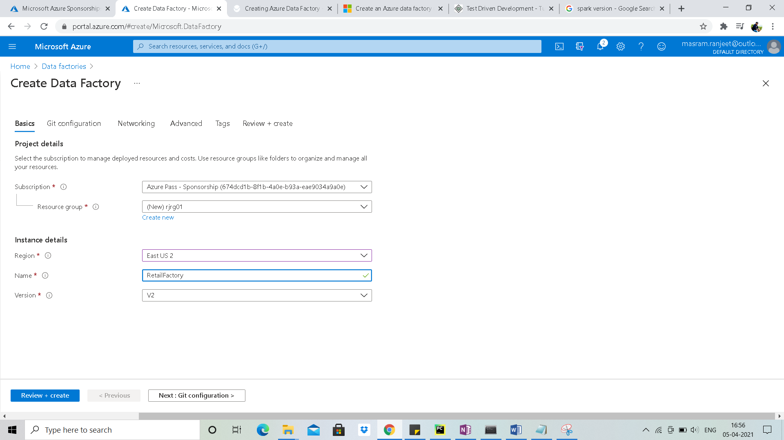

Skip Git configuration

Resource group: = rjrg01

Region: East US 2

Data Factory: rjDataFactory01

# App Registration

## Need for App Registration

* We need to retrieve data from on premise data base to Azure Data lake Storage.
* We are going to extract the data using Azure Data Factory pipeline.
* Once data is extracted we need to put this data in Azure Data Lake Storage
* Ques: **Is Azure Data Factory Having access to Azure Data Lake Storage? No**

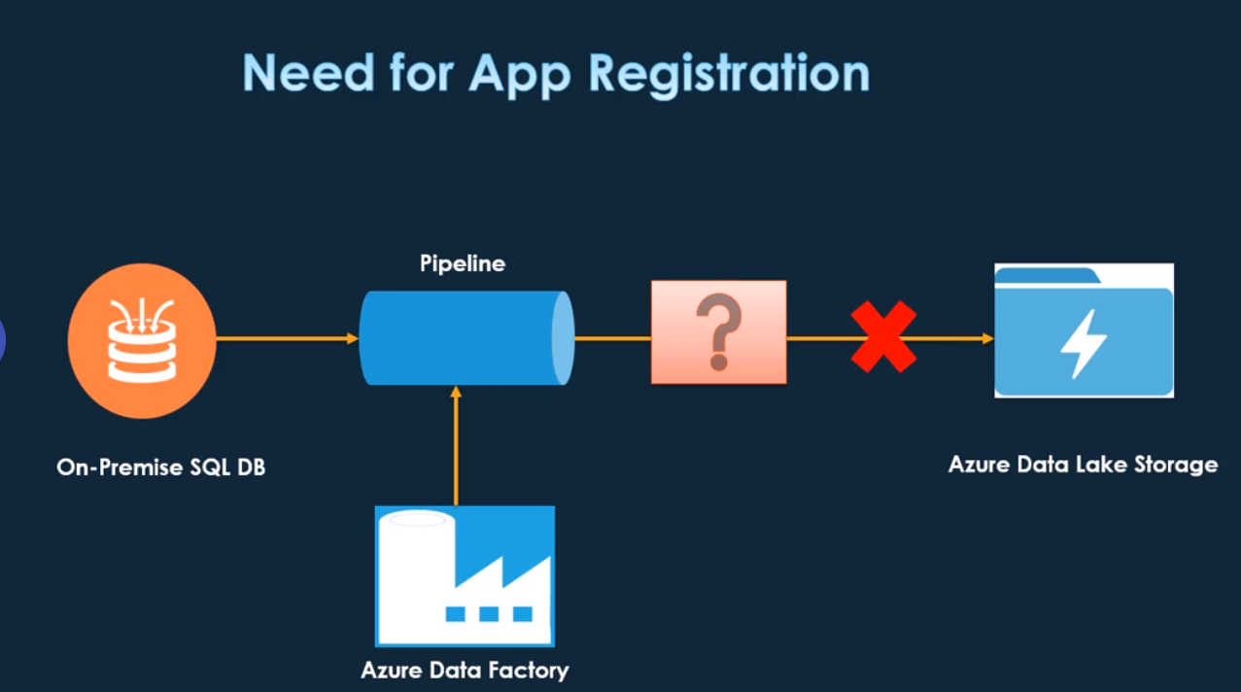

* We need to provide permission
* We need to create App Registration and provide the necessary permission so that Data Factory will get access to Azure Data Lake Storage

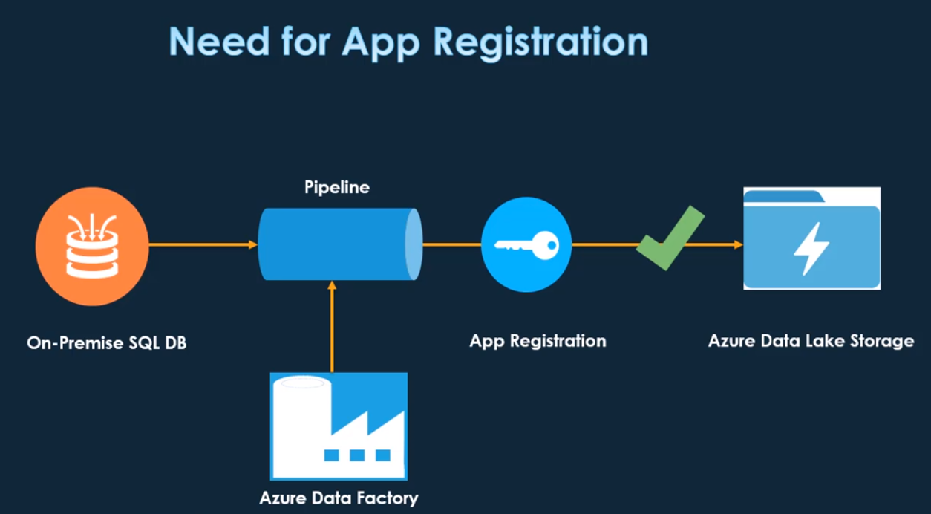

## Creating App Registration

Before app registration we need to create

* Create Azure Data Factory
* Create Azure Data Lake

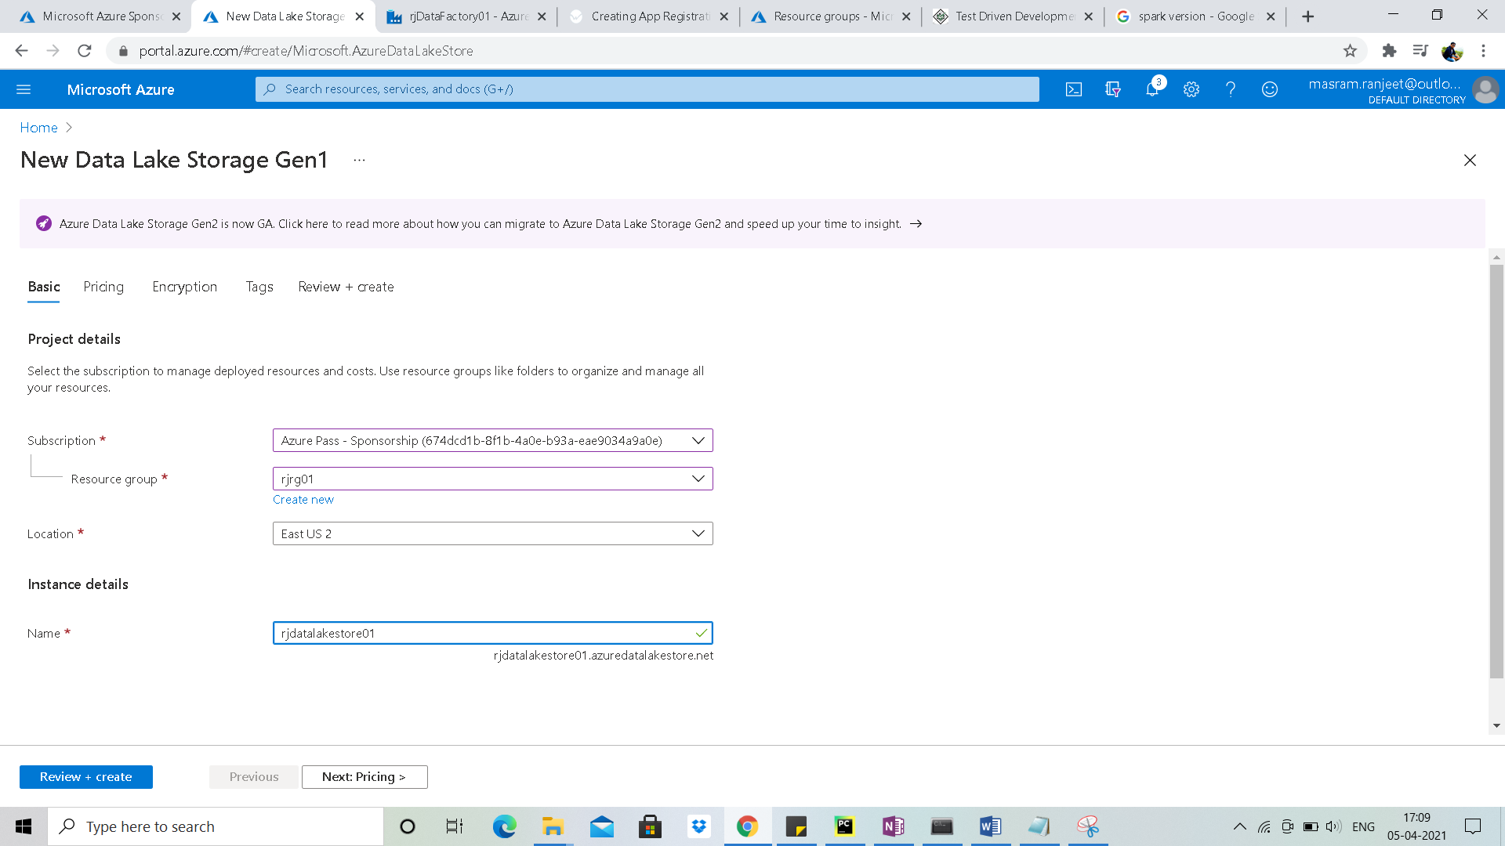

## App Registration Creation

Search for App registration

* Name: salesappregistration
* URI: <https://www.salesappregistration.com>

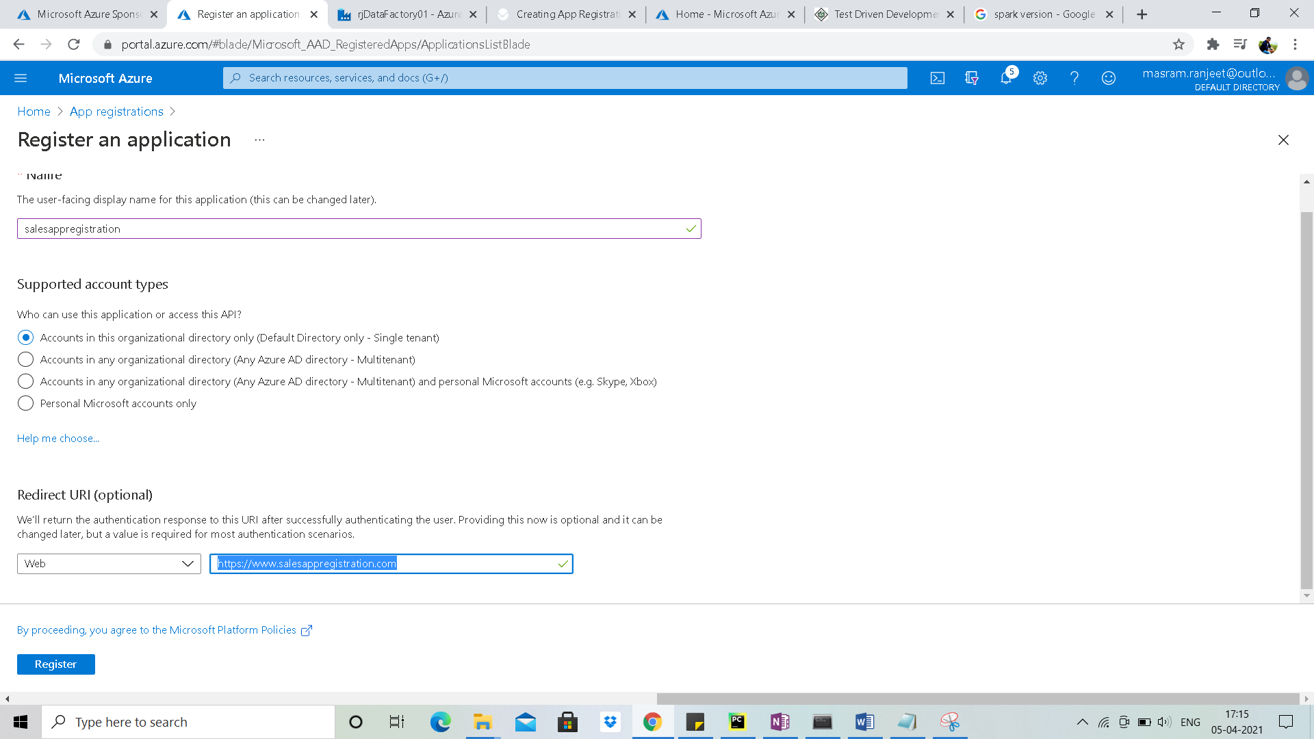

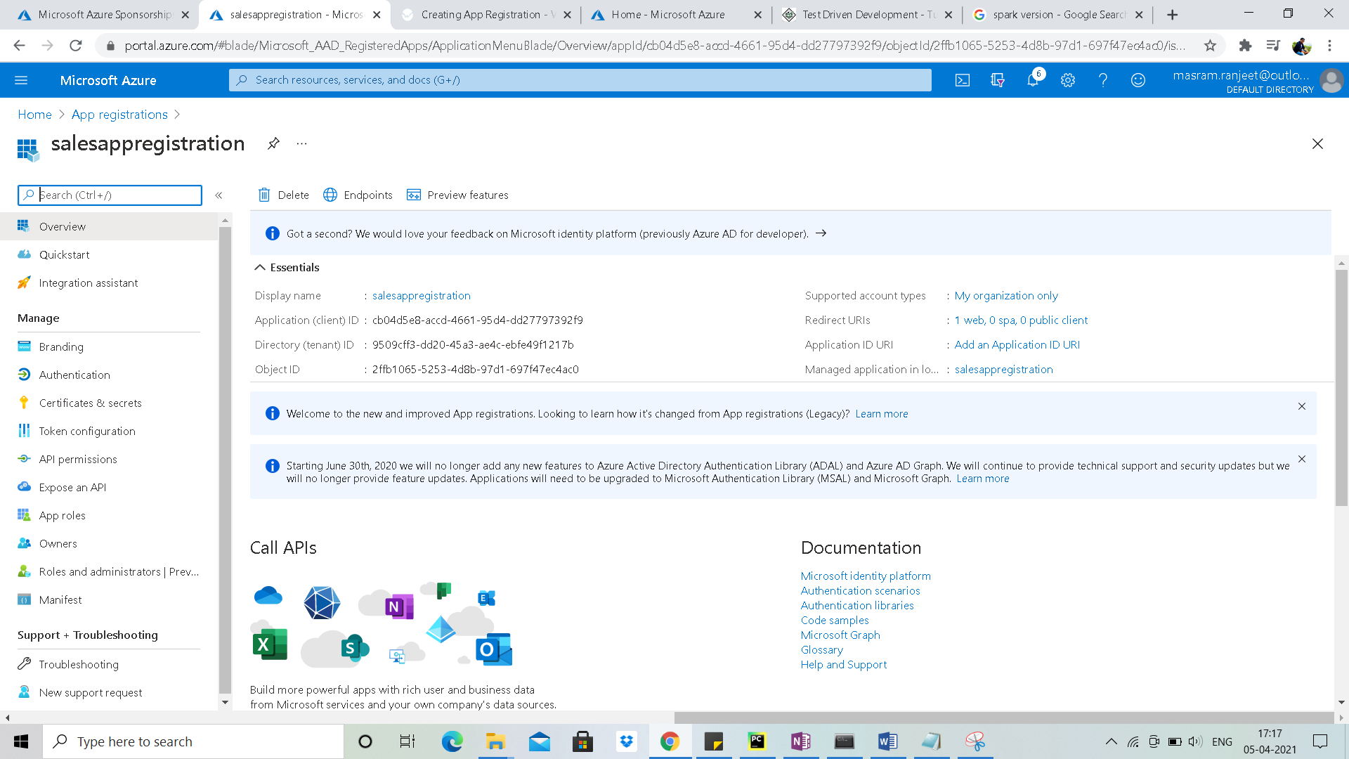

### Service principle ID

* Go to overview Tab

**Service principle ID / Application (client) ID:** cb04d5e8-accd-4661-95d4-dd27797392f9

### Generate secret key

Now we need to generate secret key

* Click on ***Certificates & Secrets*** 🡪 ***New client secret***

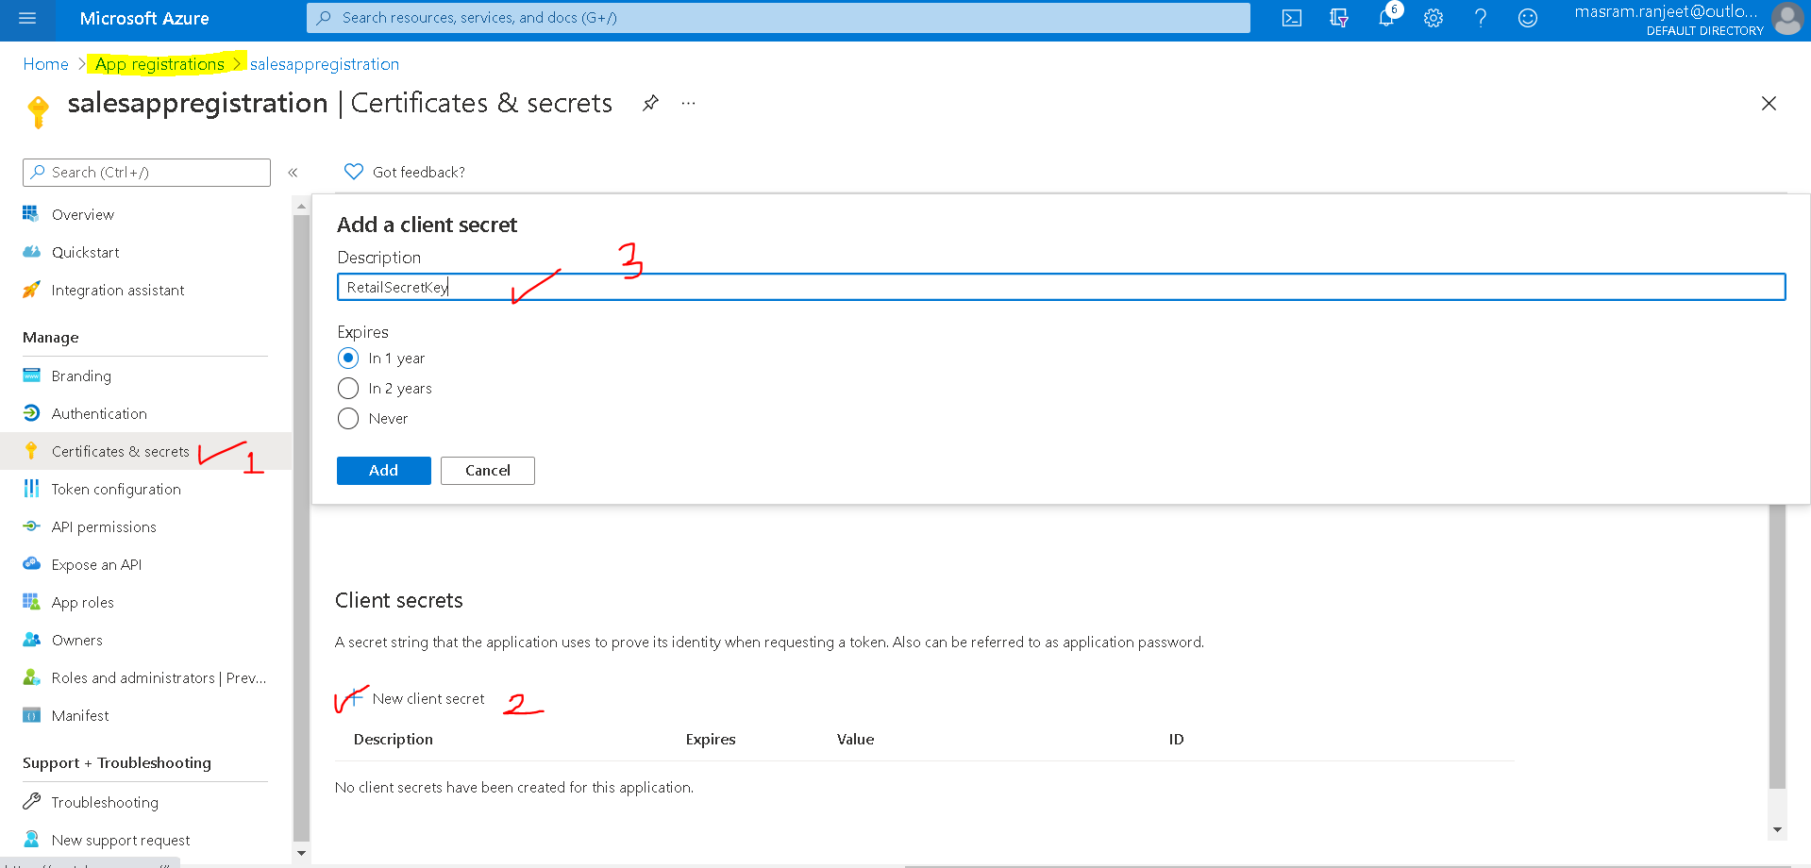

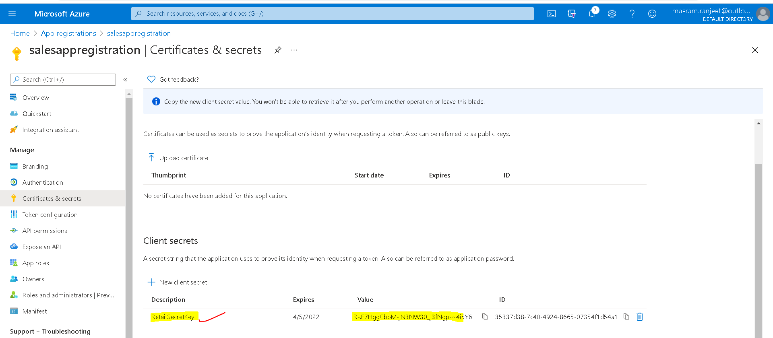

***Secret Key:*** R-.F7HggCbpM-jN3NW30_j3fNgp-~4i5Y6

***Secret Key ID:*** 35337d38-7c40-4924-8665-07354f1d54a1

We need to Application ID and Secret Key Value without pipeline

***Note:*** The secrete key will not be visible once the key is closed

## Setting App registration with Data Lake Store

* Goto Data Lake Storage create by you
* Click on Data Explorer
* If we want our App registration to have access to full Data Lake Store then we should be in root of data lake store
* Click on access

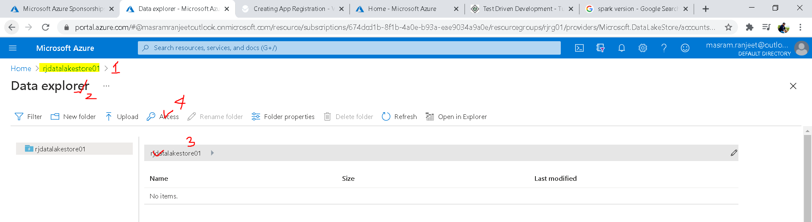

* Click on add

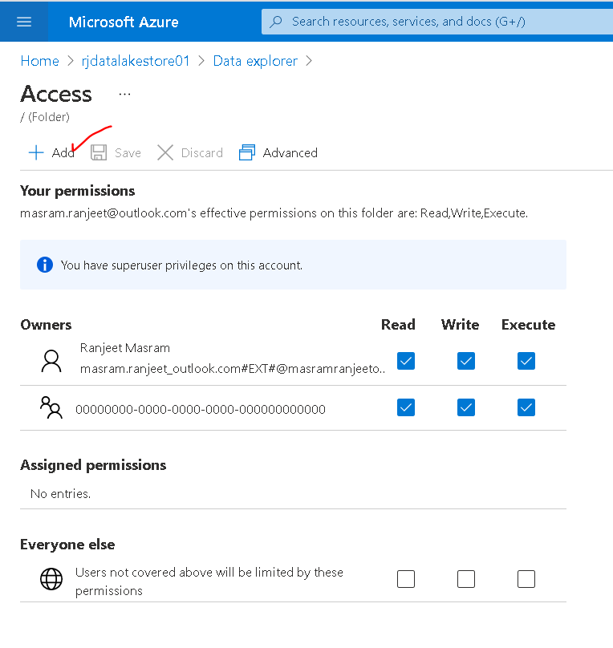

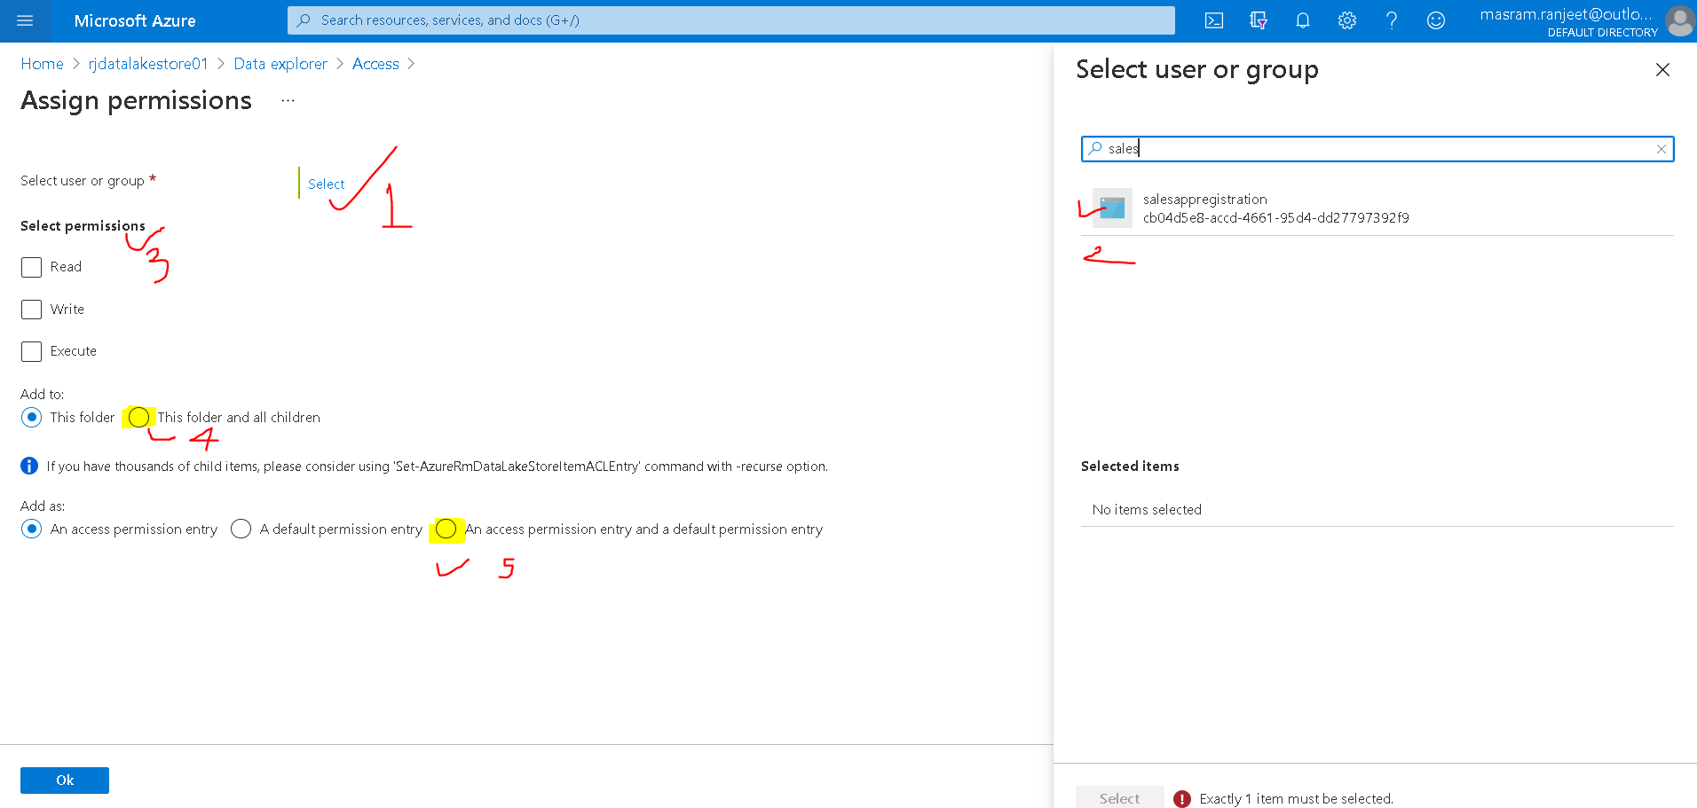

# Linked Service

## Need for Linked Services

* Linked Services are like connection strings which can define the connection information needed for Data Factory Pipeline to connect to different Sources

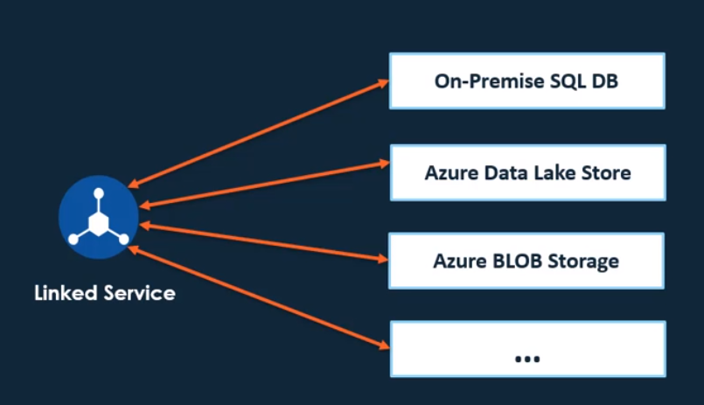

* We need two linked Services in our scenario
  + To connect to on premise DB
    - Important point for on premise DB we need to install “***Self Hosted Integration Runtime***”
  + To connect to Azure Data Lake Store
    - **Auto Resolving Integration Runtime** would be used as we are connecting to cloud storage

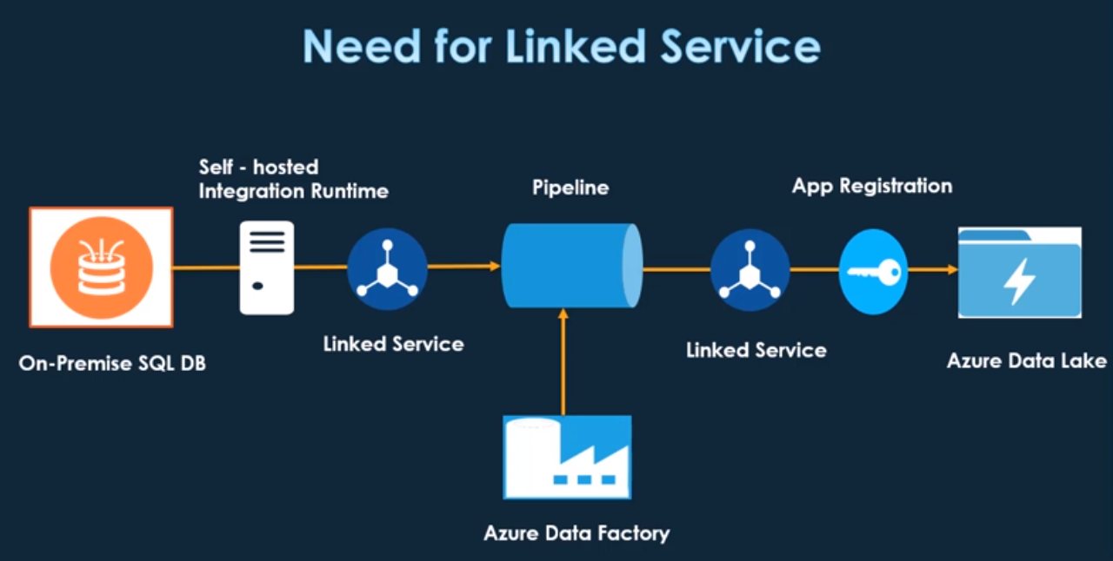

## Creating Linked Service

### Creating Linked Service for On-premise SQL DB

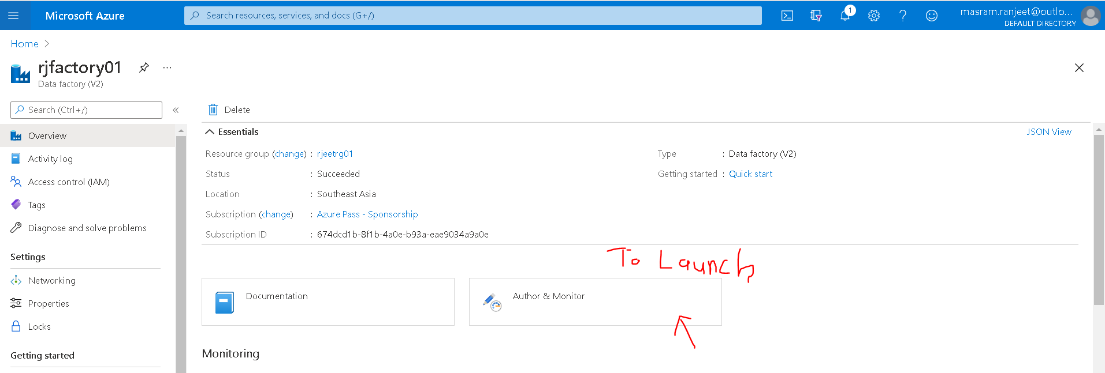

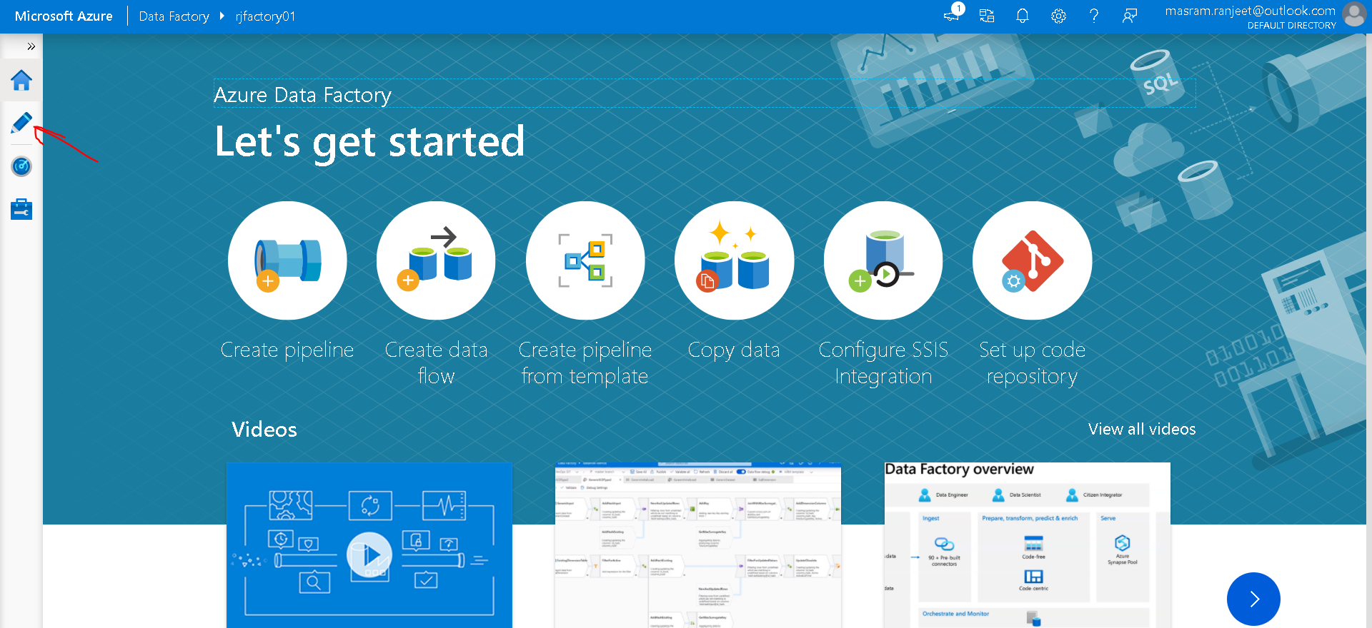

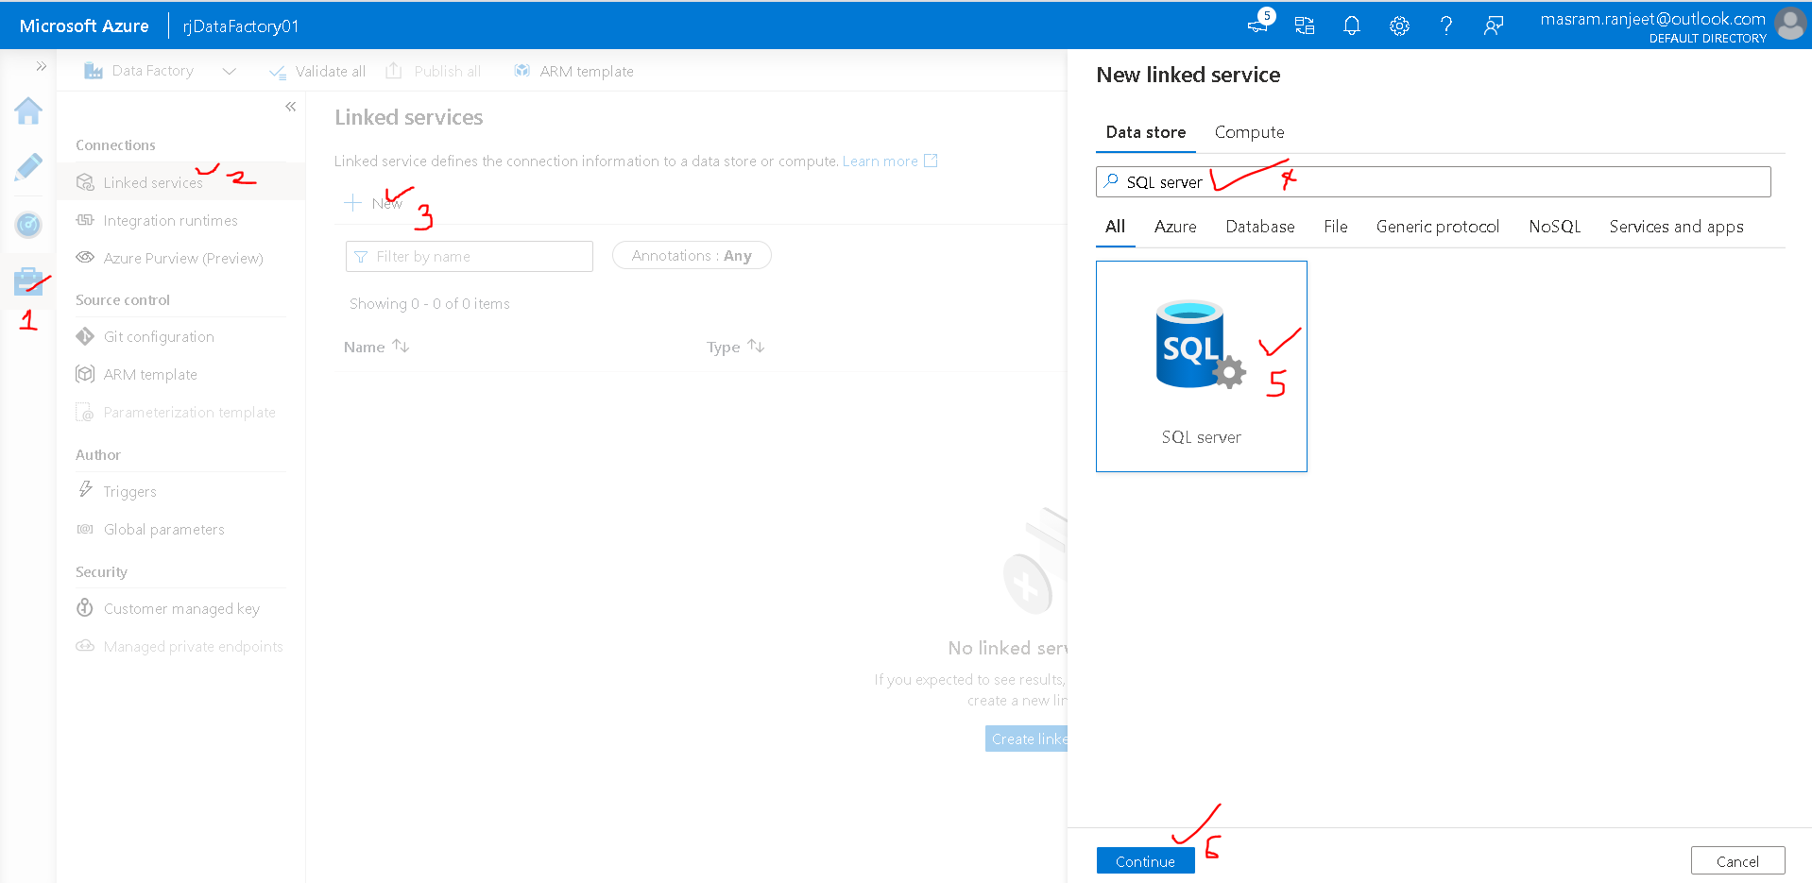

Connect via Integration Runtime: New (For on Primise DB)

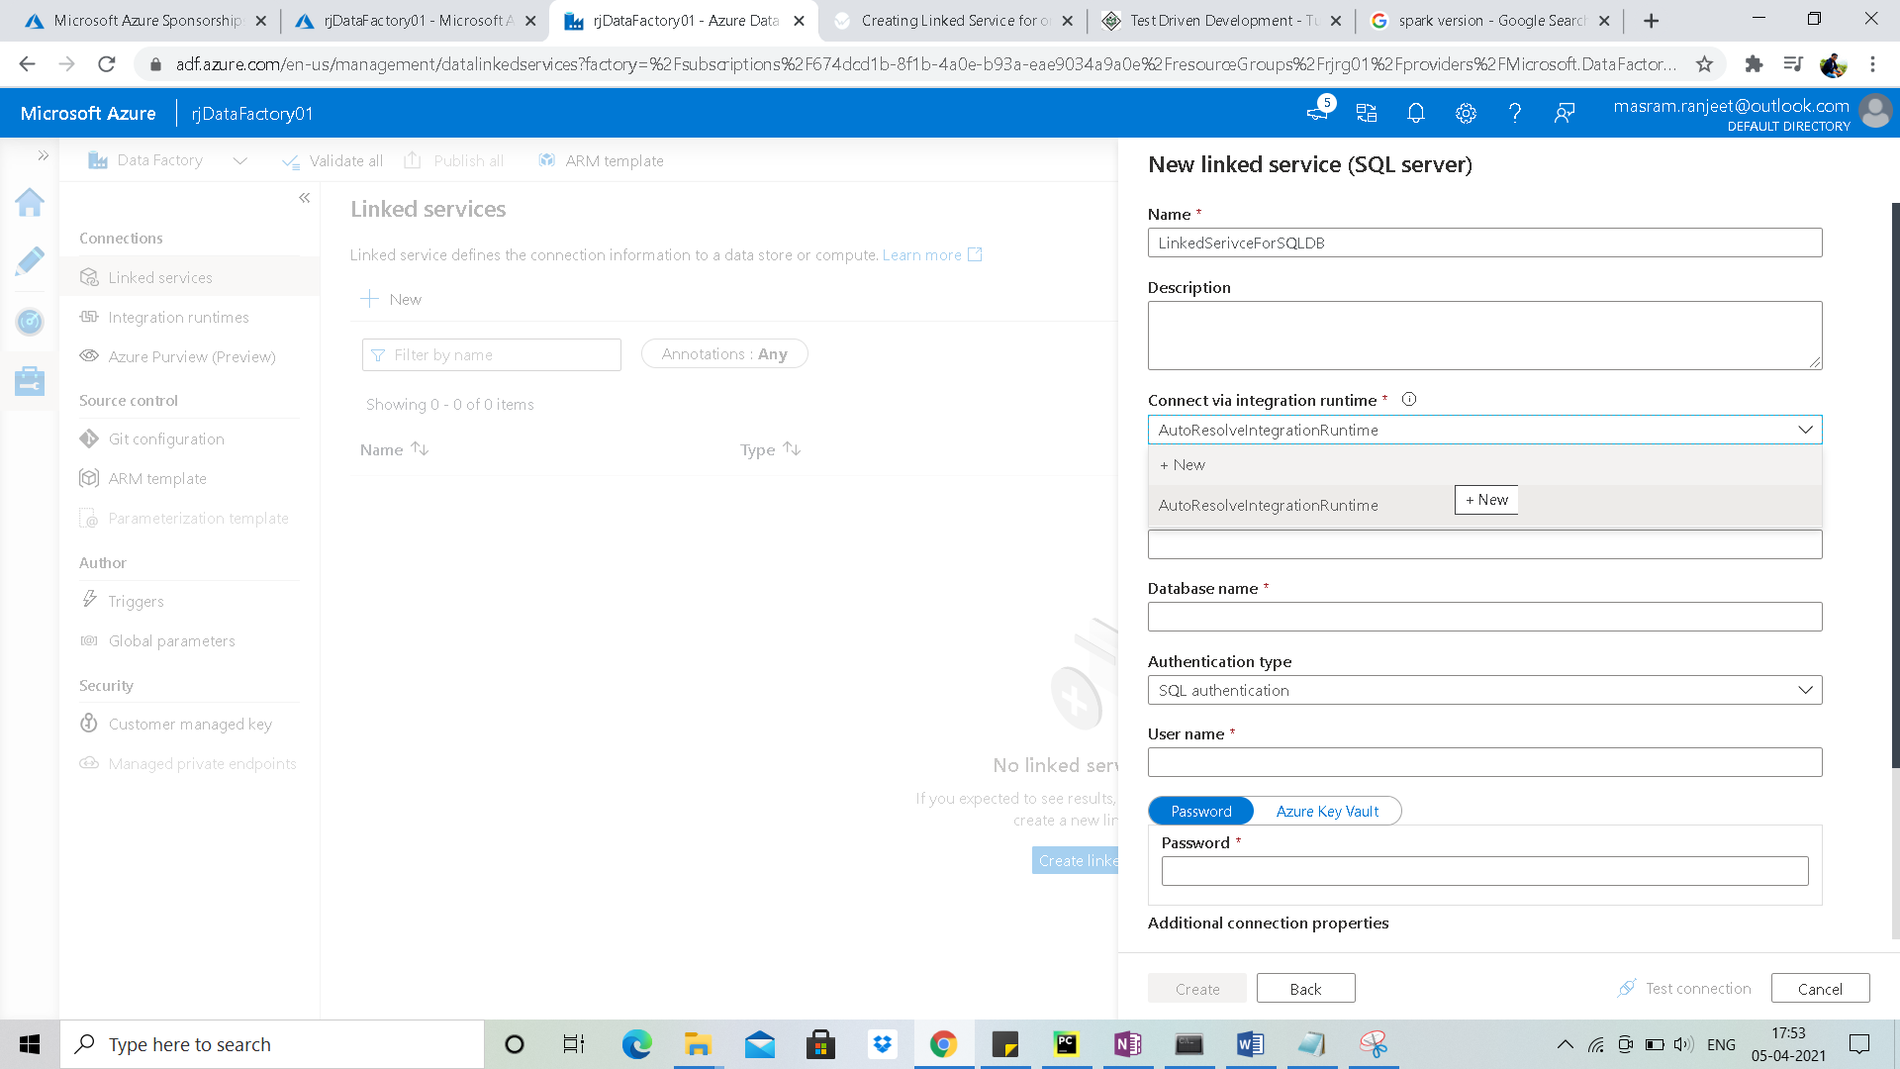

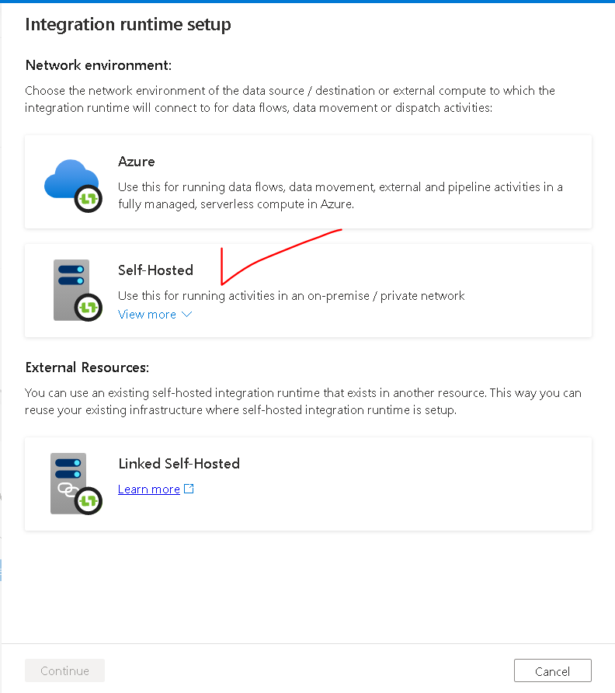

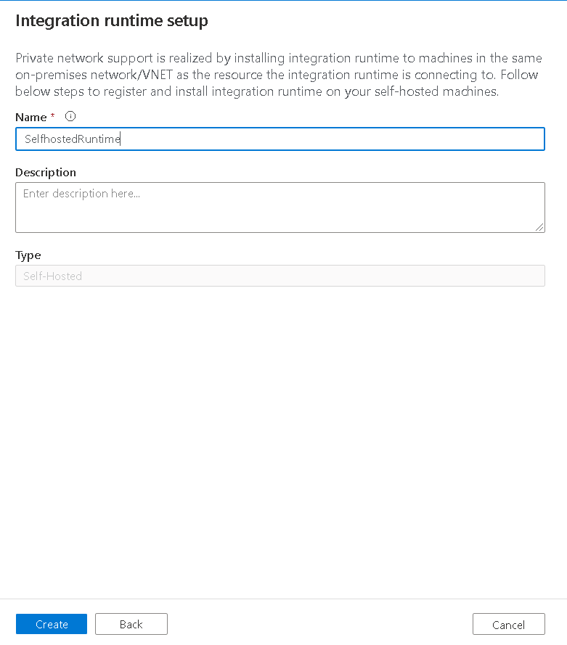

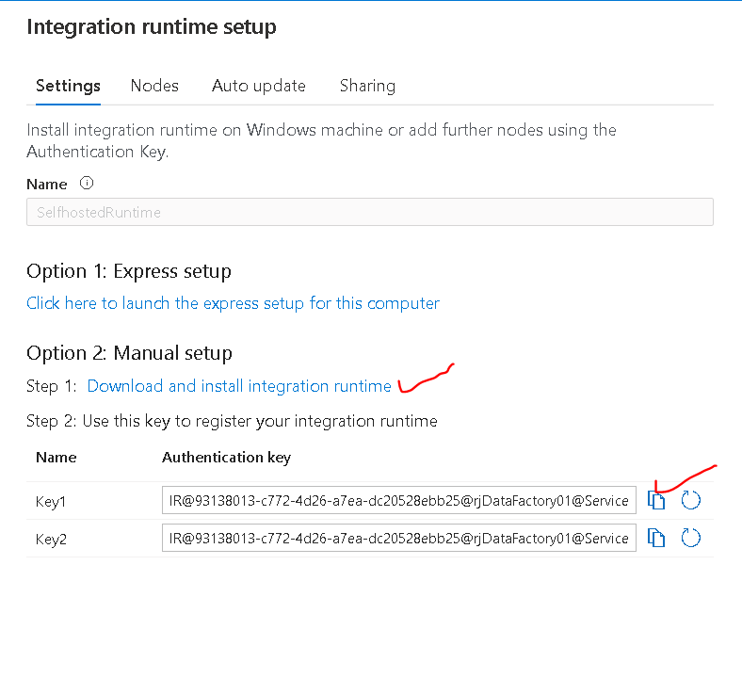

Download and Install integration Runtime on local system and

Integration runtime setup key –

[IR@93138013-c772-4d26-a7ea-dc20528ebb25@rjDataFactory01@ServiceEndpoint=rjdatafactory01.eastus2.datafactory.azure.net@iVmrrc+NBF708Huo0EG/568RQ6dKyp26DBbSn9hHlMk](mailto:IR@93138013-c772-4d26-a7ea-dc20528ebb25@rjDataFactory01@ServiceEndpoint=rjdatafactory01.eastus2.datafactory.azure.net@iVmrrc+NBF708Huo0EG/568RQ6dKyp26DBbSn9hHlMk)=

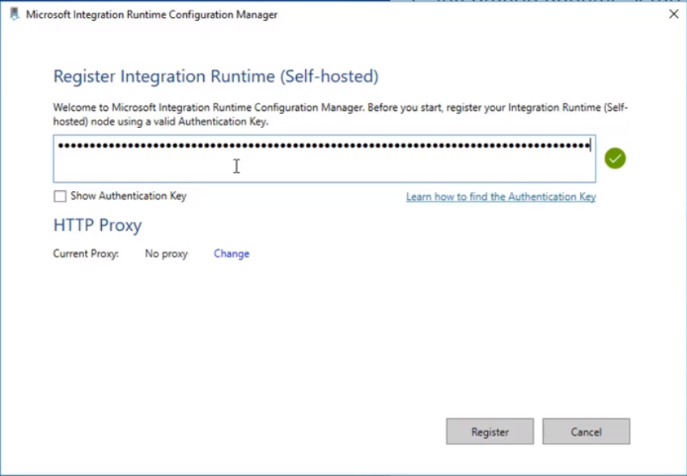

On Azure Data Factory

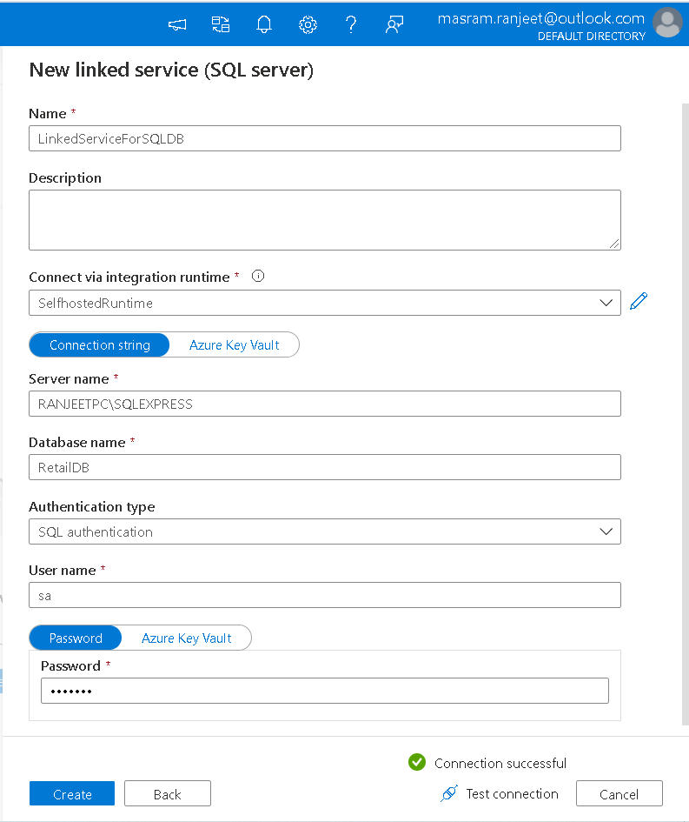

### Creating Linked Service for Azure Data Lake Store

Prerequisites

* Data Lake Store
* Copy Service Principle ID and Secret key of App Registration

Goto Data Factory UI 🡪Manage 🡪 Linked Service 🡪 New 🡪 Azure Data Lake Storage (Gen1 or Gen2 which you want to connect)

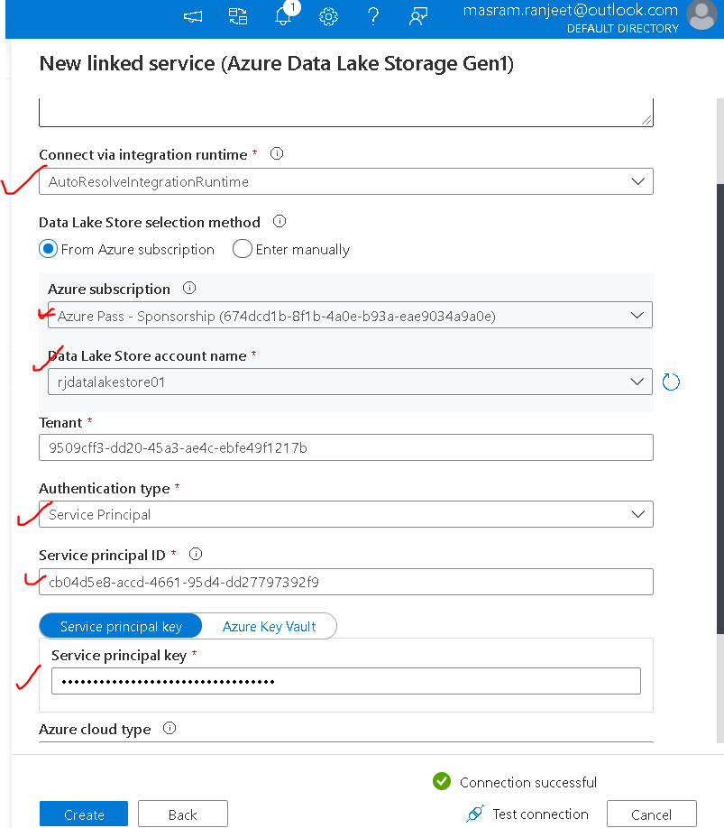

Paste Service Principal ID and Service Principal Key copied during app registration

# Dataset

## Need for Dataset

In this scenario we need two data sets

* For input of an activity
* Output dataset to represent the output of activity in the pipeline

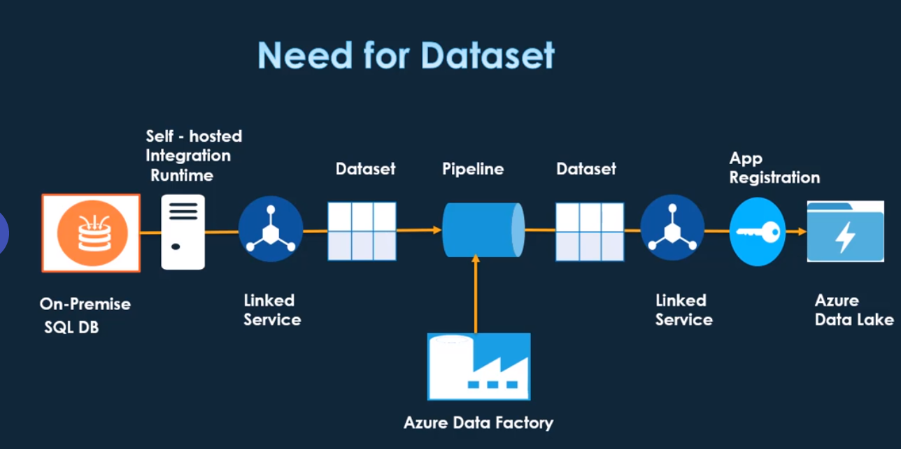

## Creating dataset for on-premise SQL DB

Go to Azure Data Factory UI 🡪 Author🡪 Dataset 🡪 new

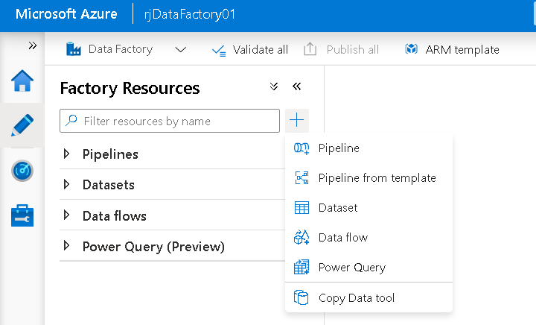

SQL Server

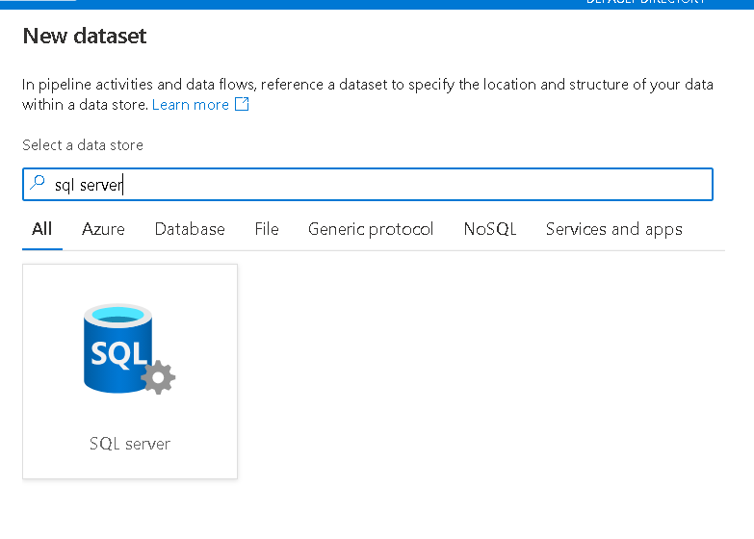

Select the Linked Service created for SQL on premise DB. Click OK

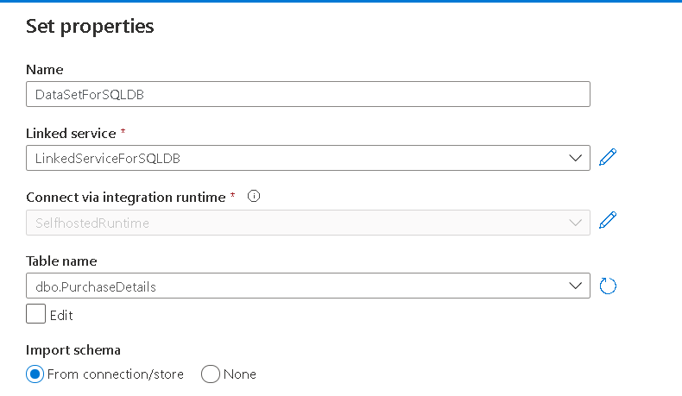

Import schema will import the schema

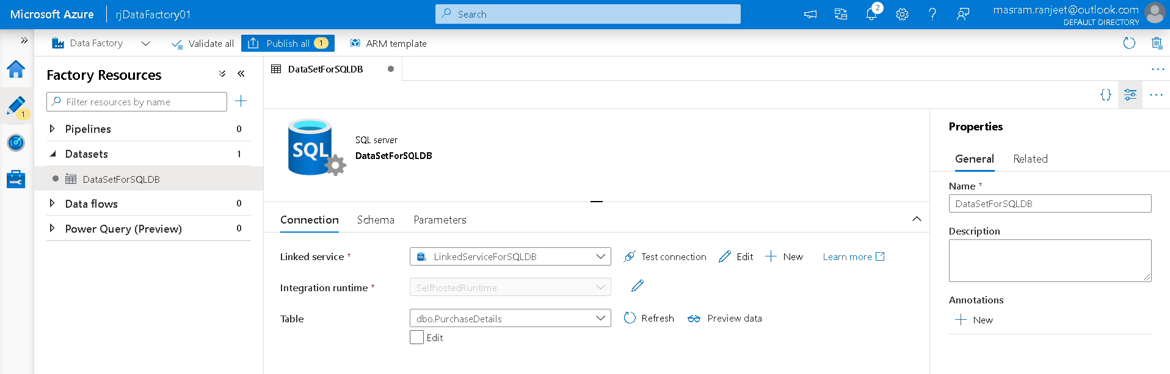

Annotation can be used to create a tag to the dataset and we could monitor the execution by mentioning the tag.

To save the Dataset we need to publish to import the changes

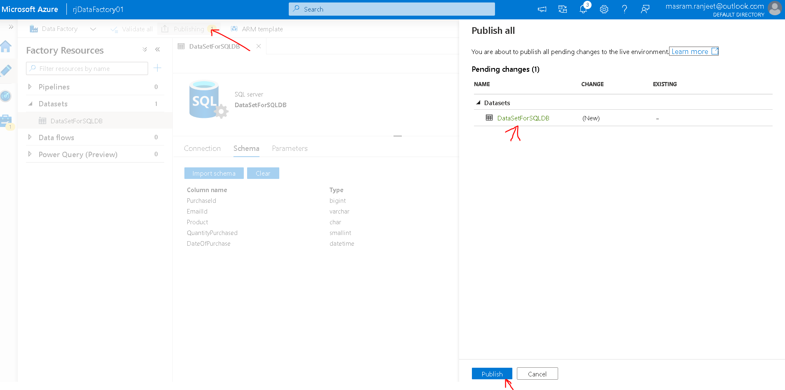

## Creating dataset for Azure Data Lake

Go to Azure Data Factory UI 🡪 Author🡪 Dataset 🡪 new

Select **Azure Data Lake Storage Gen 1**

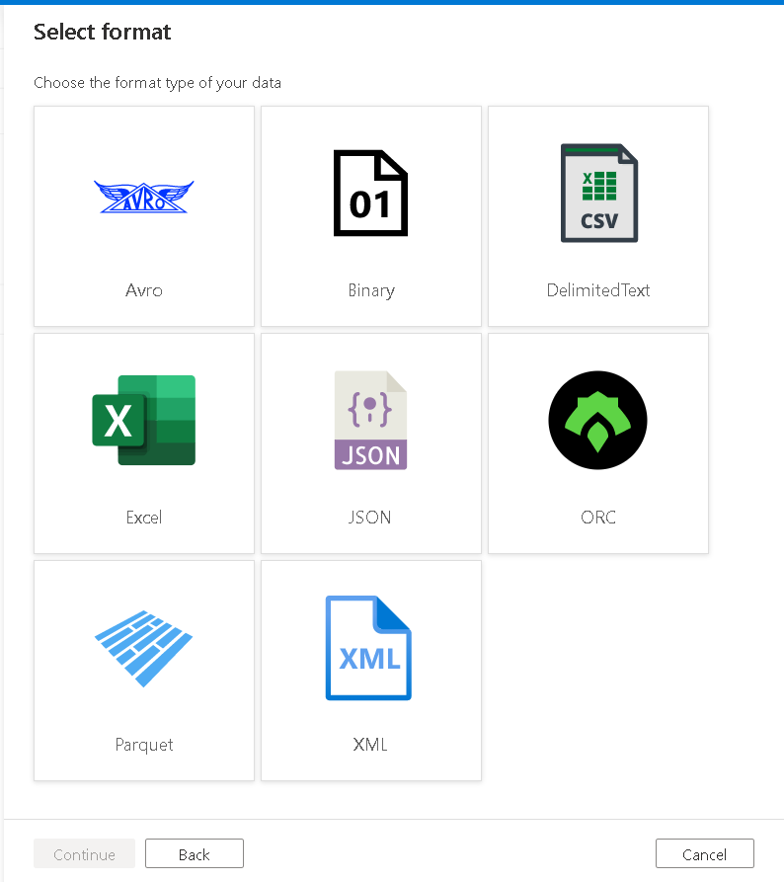

ORC – For hive data

**We are selecting DelimitedText**

Select the linked Service created for Data Lake

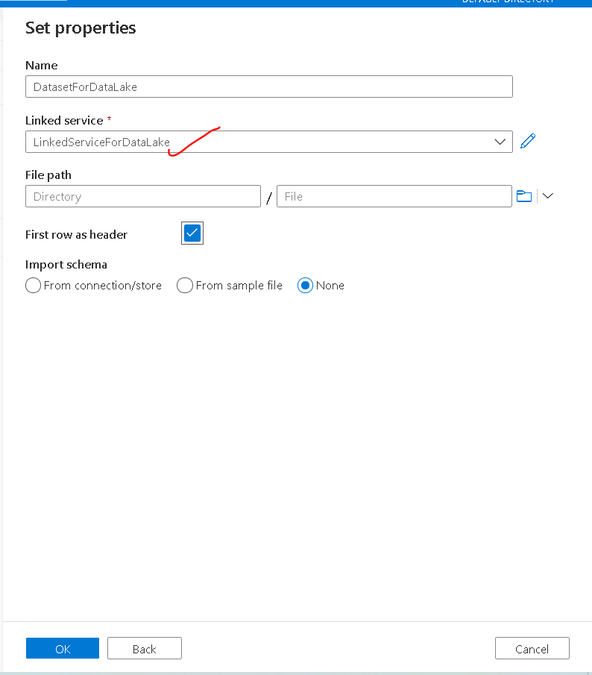

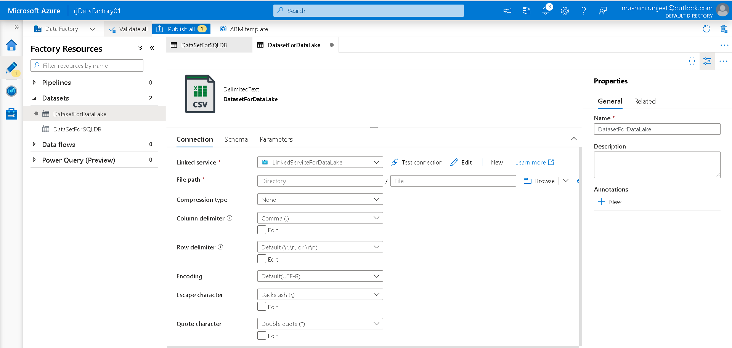

For **File Path** we need to provide the path to store the data which is extracted from on Premise SQL DB

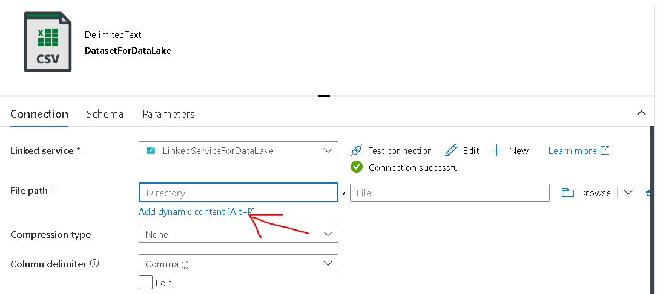

Enter dynamic content and give file name as sales

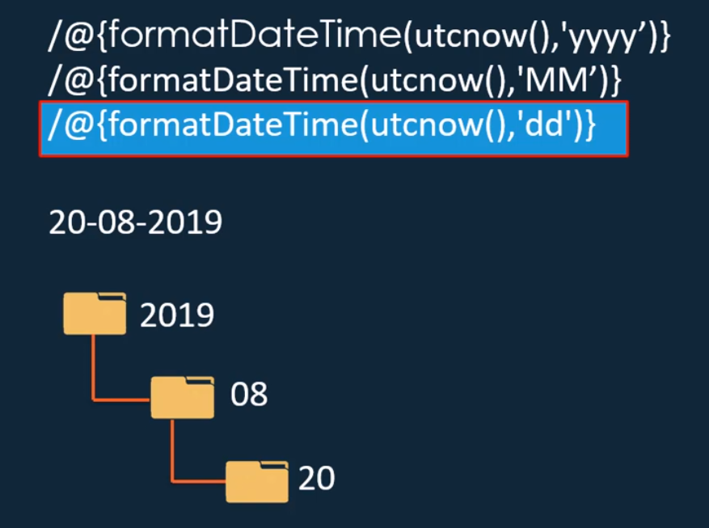 /@{formatDateTime(utcnow(),'yyyy')}/@{formatDateTime(utcnow(),'MM')}/@{formatDateTime(utcnow(),'dd')}

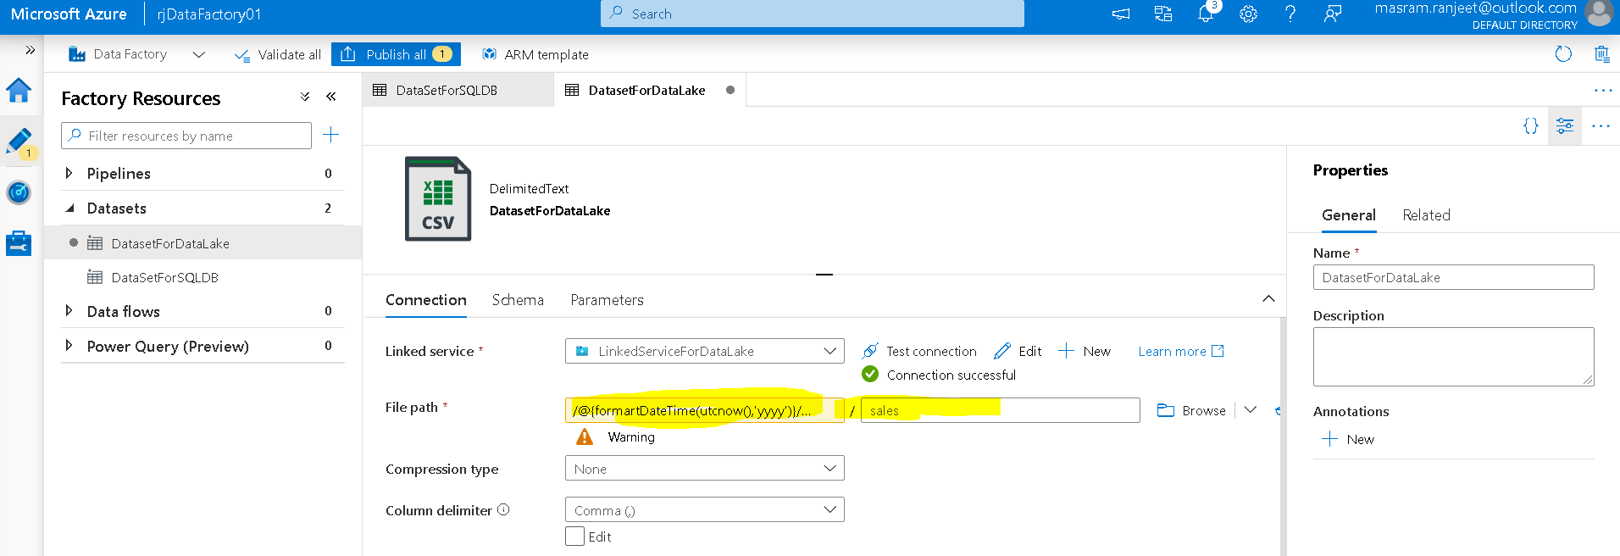

Publish the changes

# Working with Pipeline

Pipeline is nothing but set of activities

## Creating Pipeline to copy the data from on-premise SQL DB

Go to Azure Data Factory UI 🡪 Author 🡪 Pipeline🡪new

Activities 🡪 Move & Transform 🡪 Copy

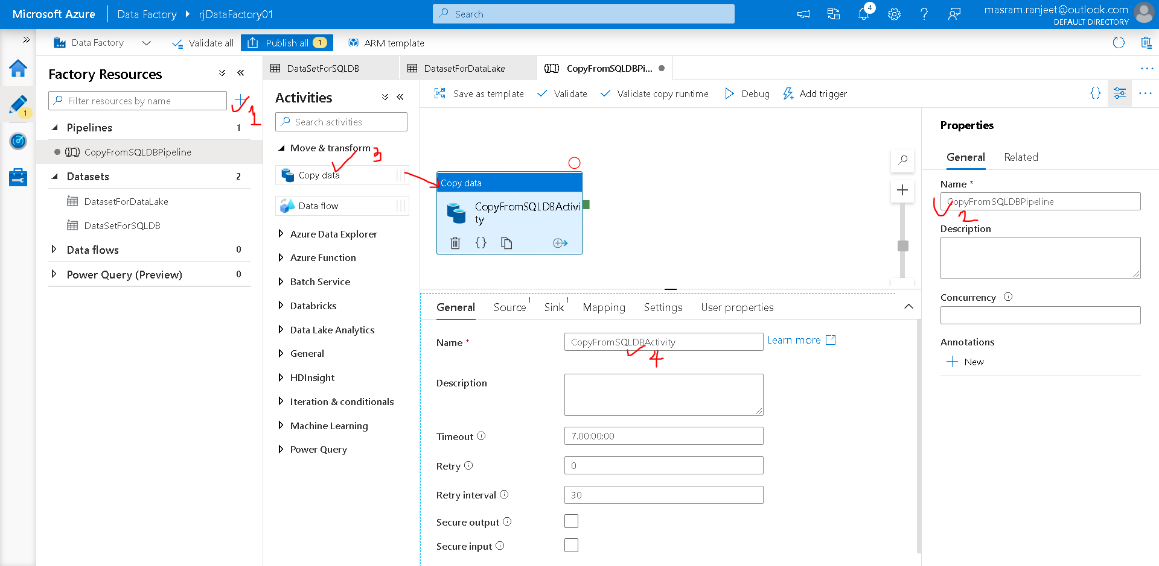

Source Tab

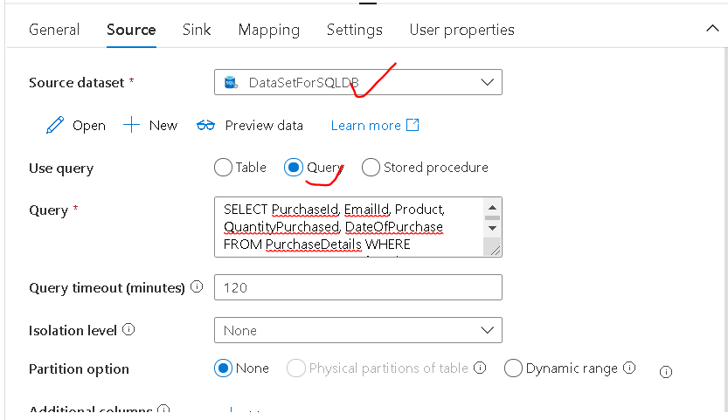

**Query**

SELECT PurchaseId, EmailId, Product, QuantityPurchased, DateOfPurchase FROM PurchaseDetails WHERE CONVERT(DATE, DateOfPurchase) = '@{formatDateTime(utcnow(),'yyyy-MM-dd')}'

Sink – sink is destination

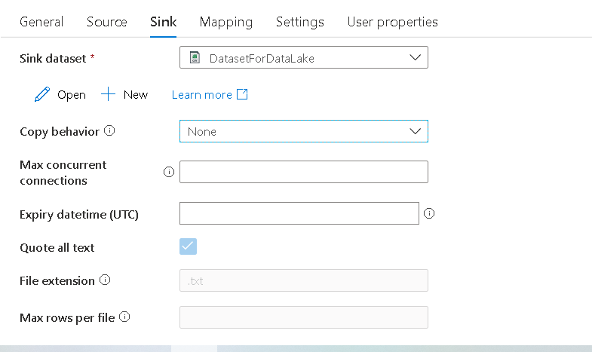

Mapping 🡪 import schema

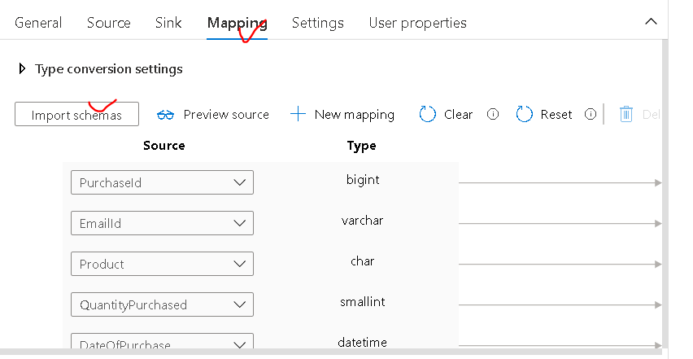

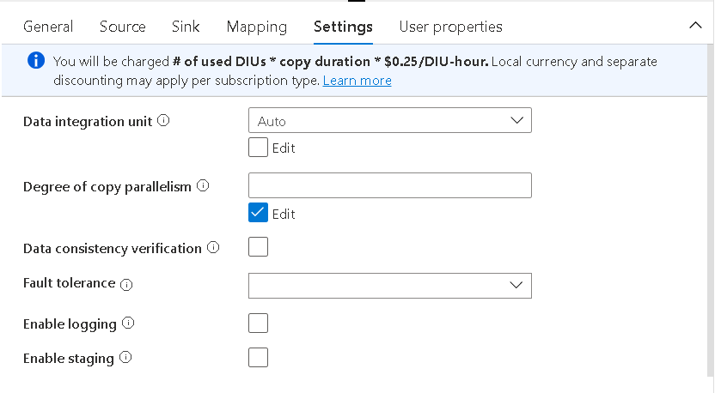

Publish changes to save pipeline

## Executing Pipeline

Select the pipeline 🡪 Debug

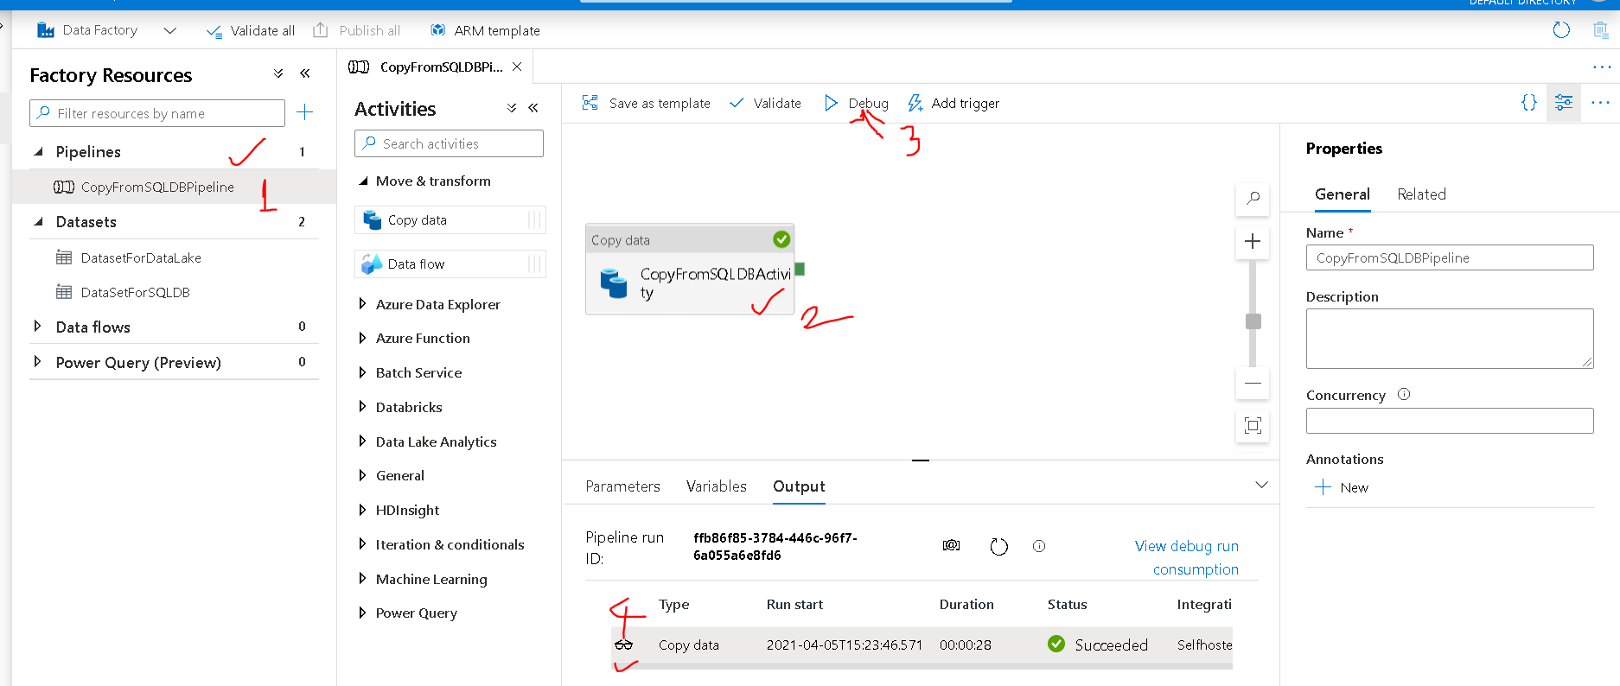

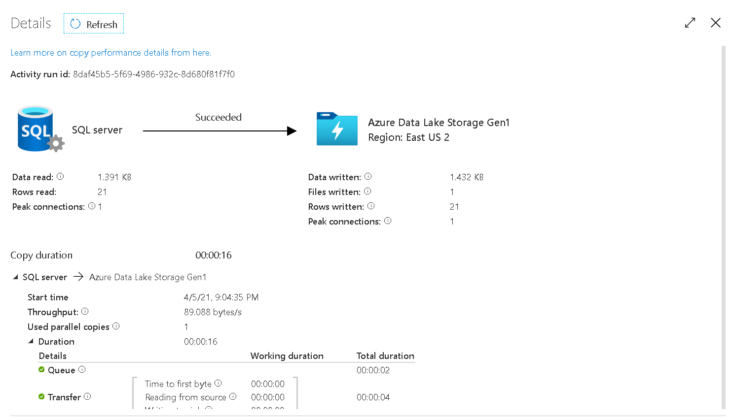

We could go to Azure Portal and check in Azure Data Lake Store

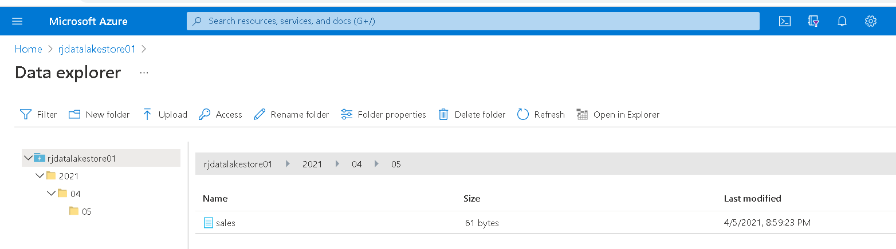

## Creating Pipeline to copy the data from Azure BLOB storage

We will copy the data from Azure Blob Storage to Azure Datalake Store

Prerequisite

* Azure Blob storage (Create storage Account)

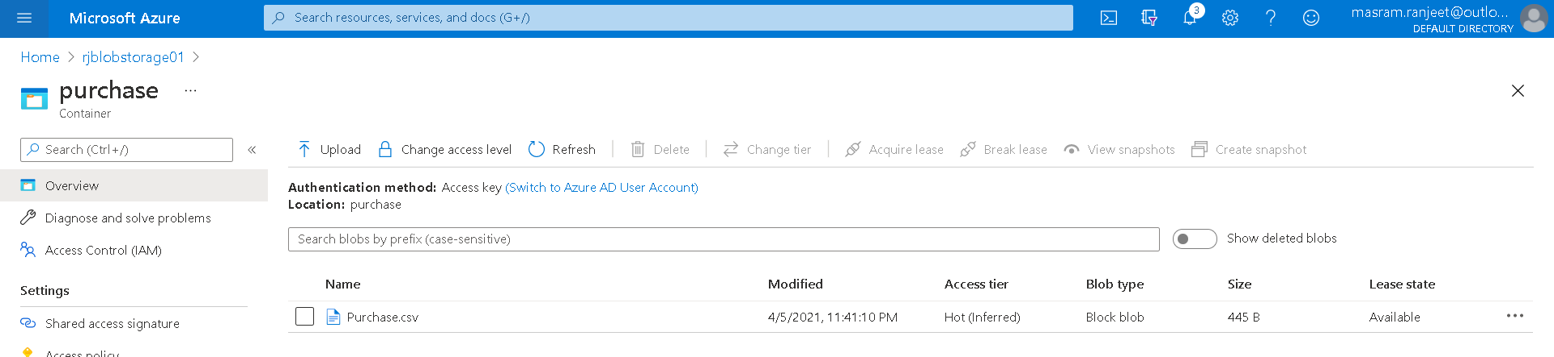

Go to Azure Data Factory

Here we are using **Copy Data Tool**

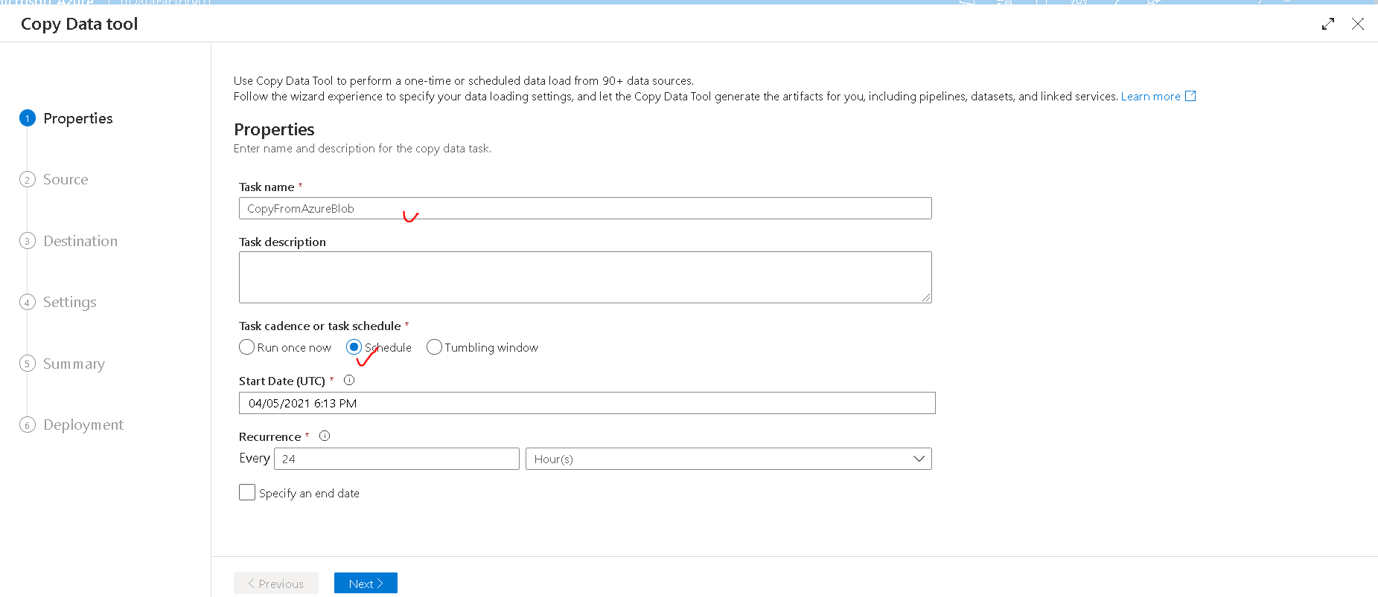

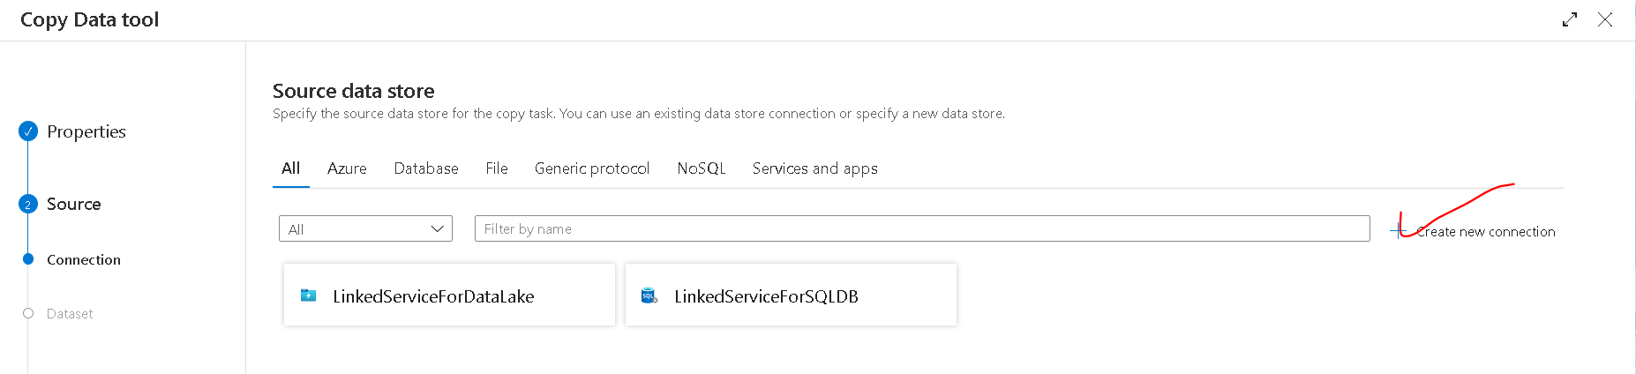

Select **Azure Blob storage**

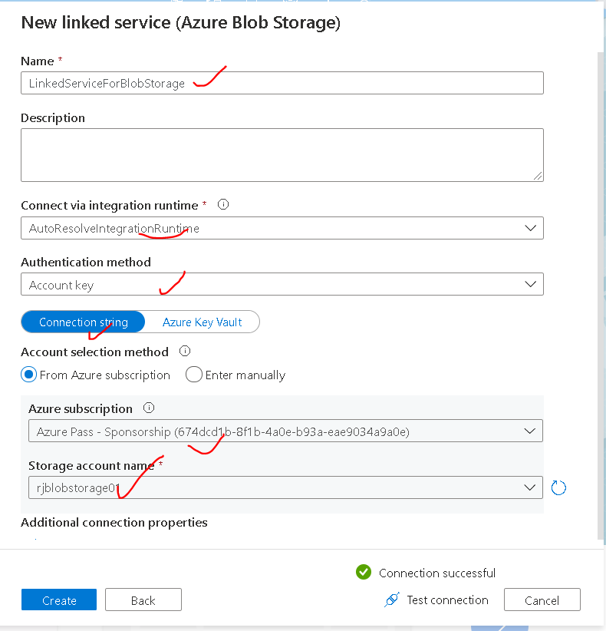

Next

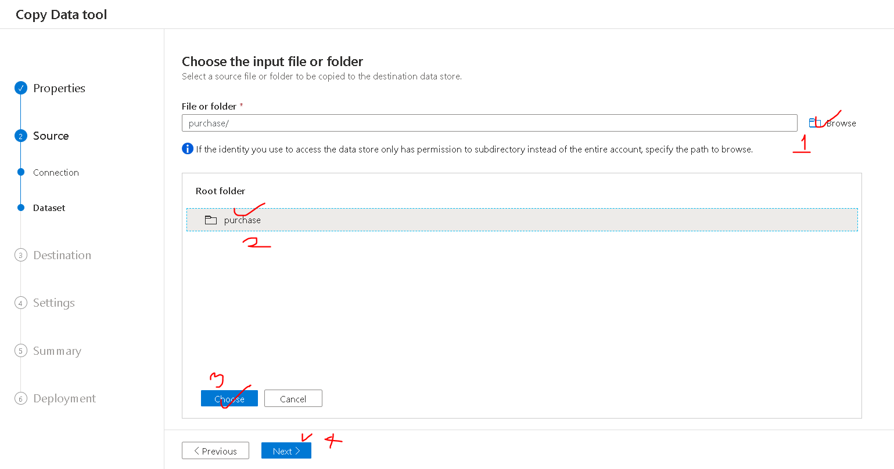

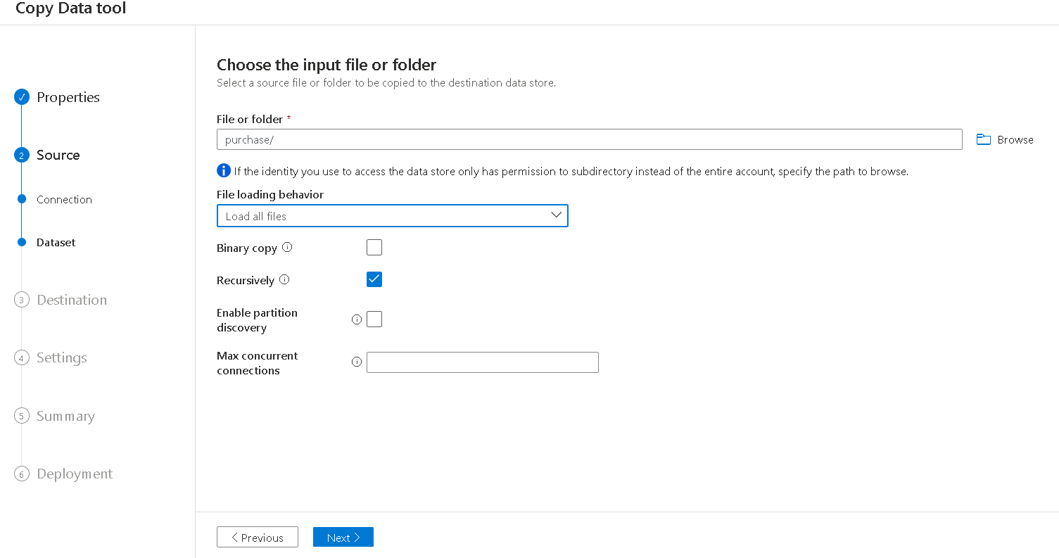

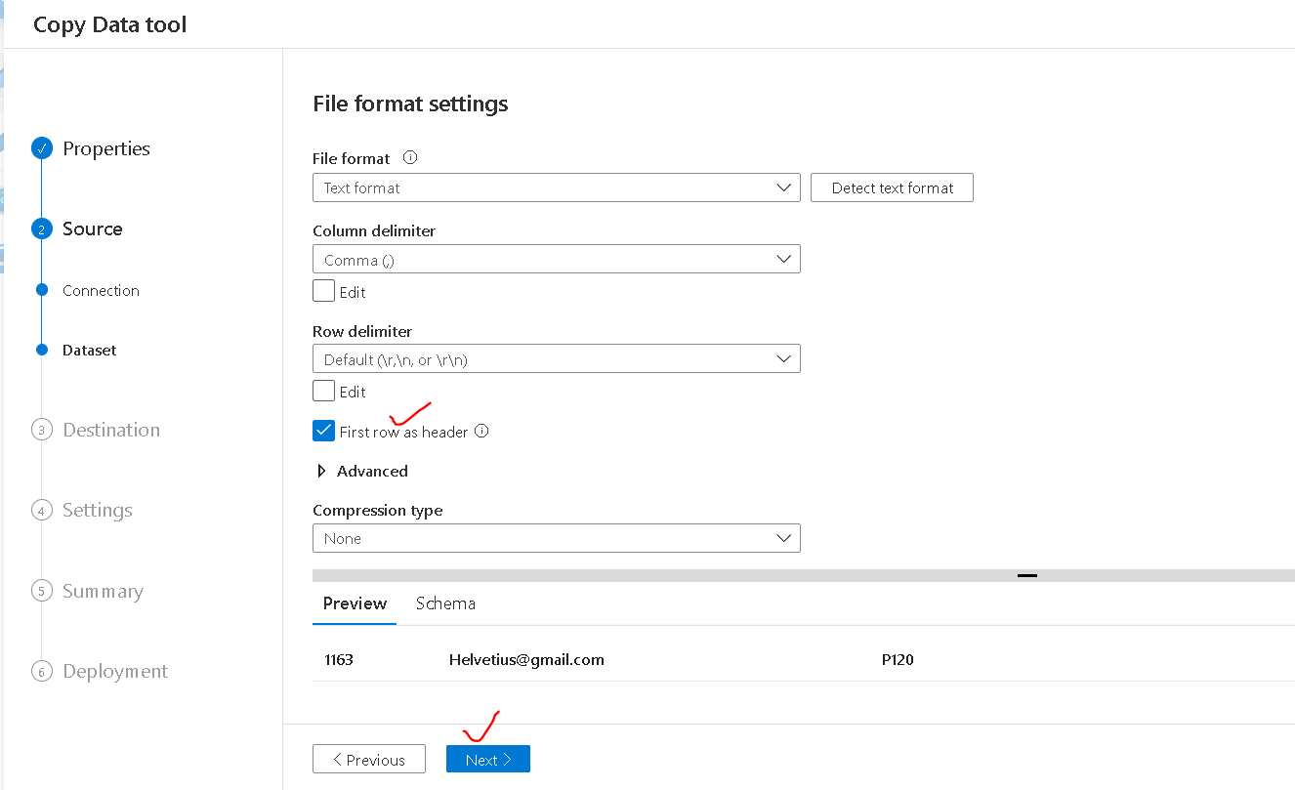

We want to connect to Data Lake we have already created a connection to connect to Data Lake

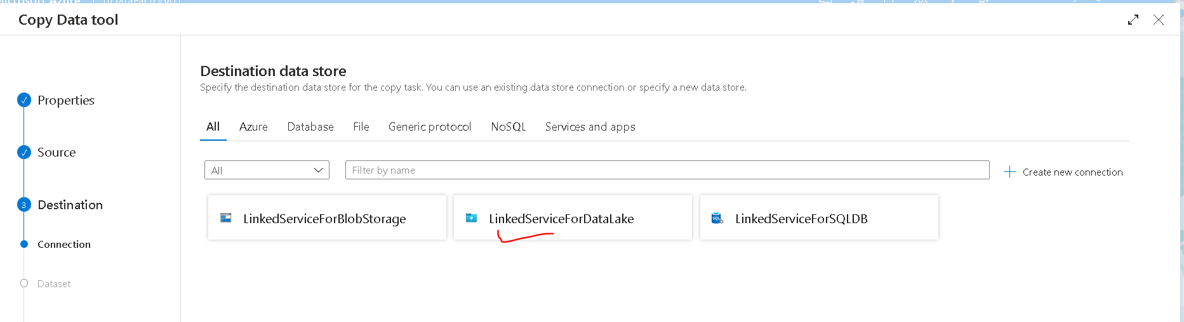

/@{formatDateTime(utcnow(),'yyyy')}/@{formatDateTime(utcnow(),'MM')}/@{formatDateTime(utcnow(),'dd')}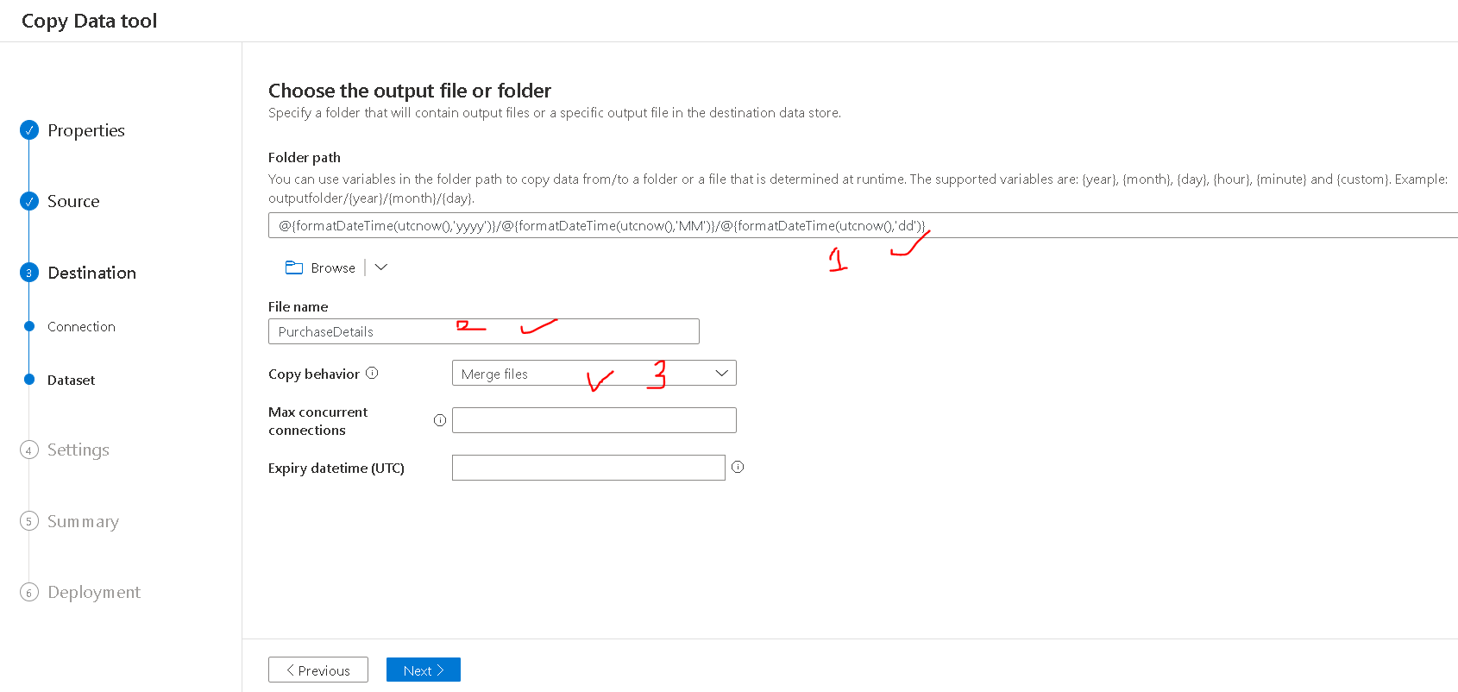

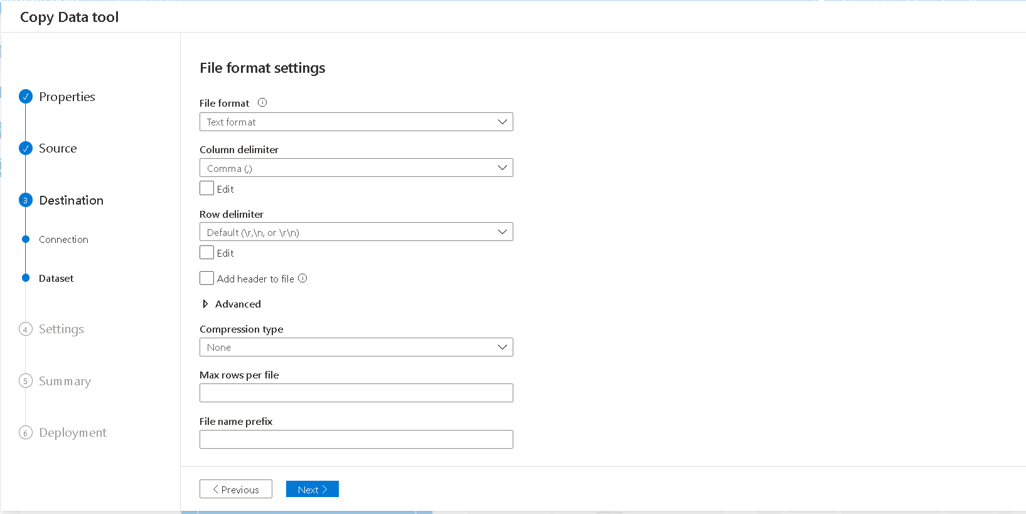

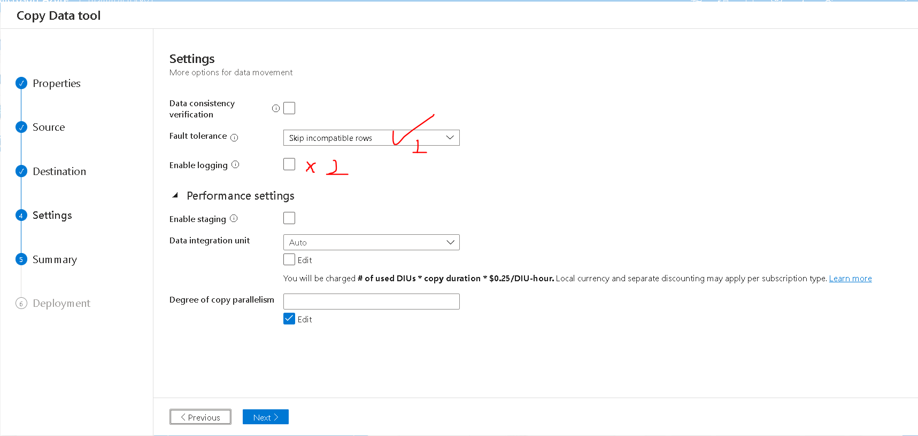

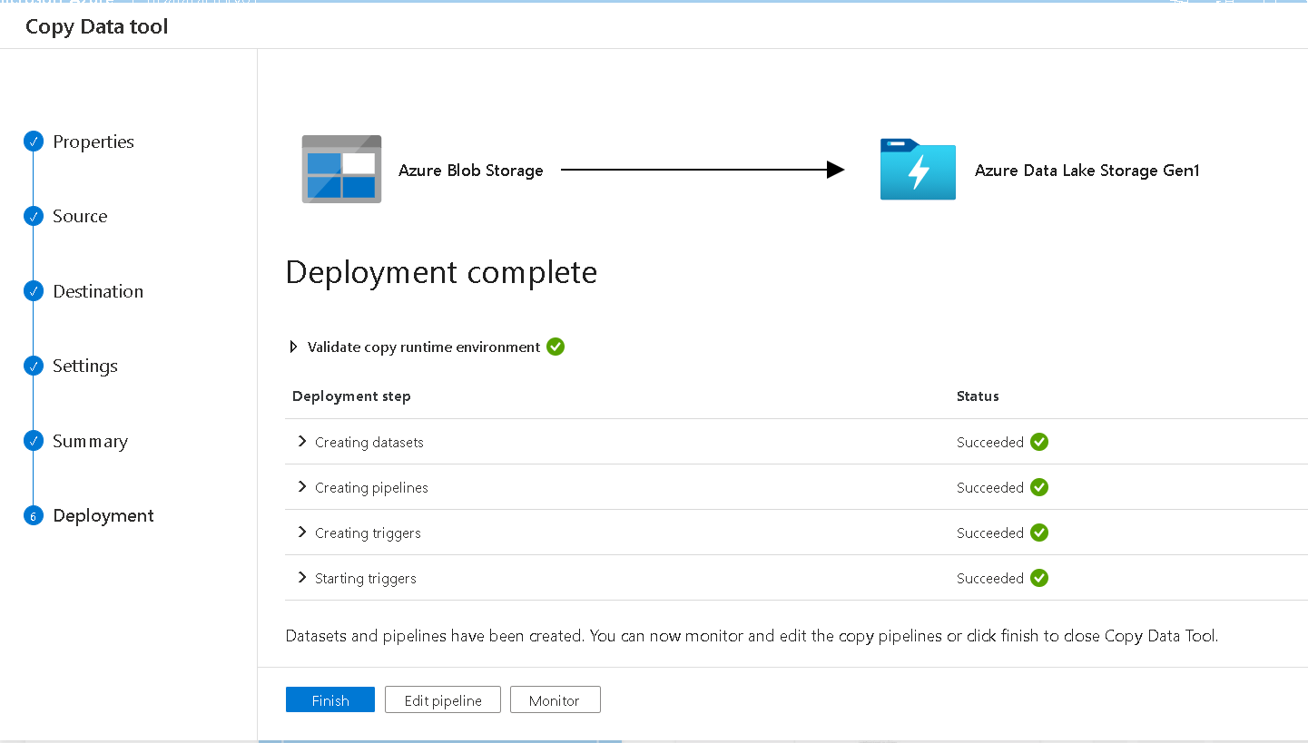

Executing

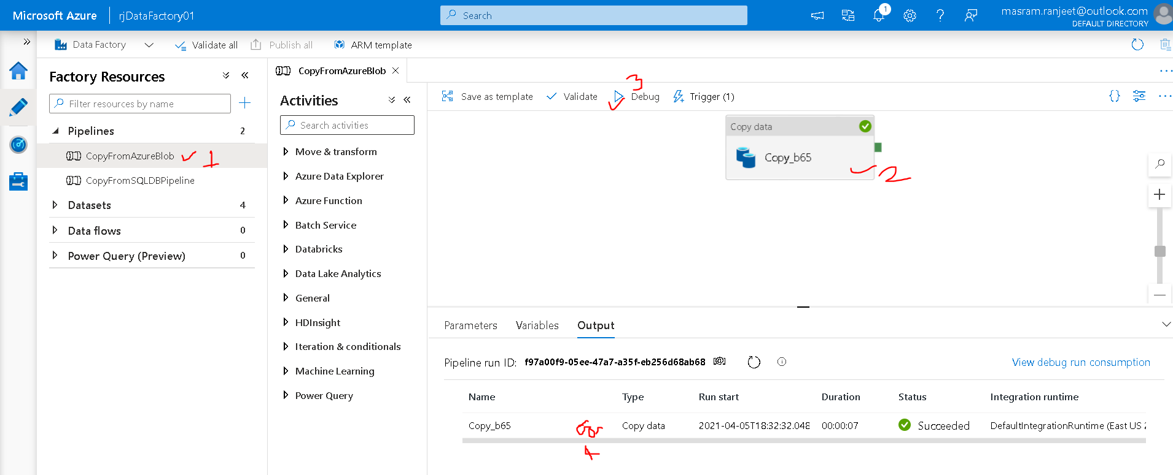

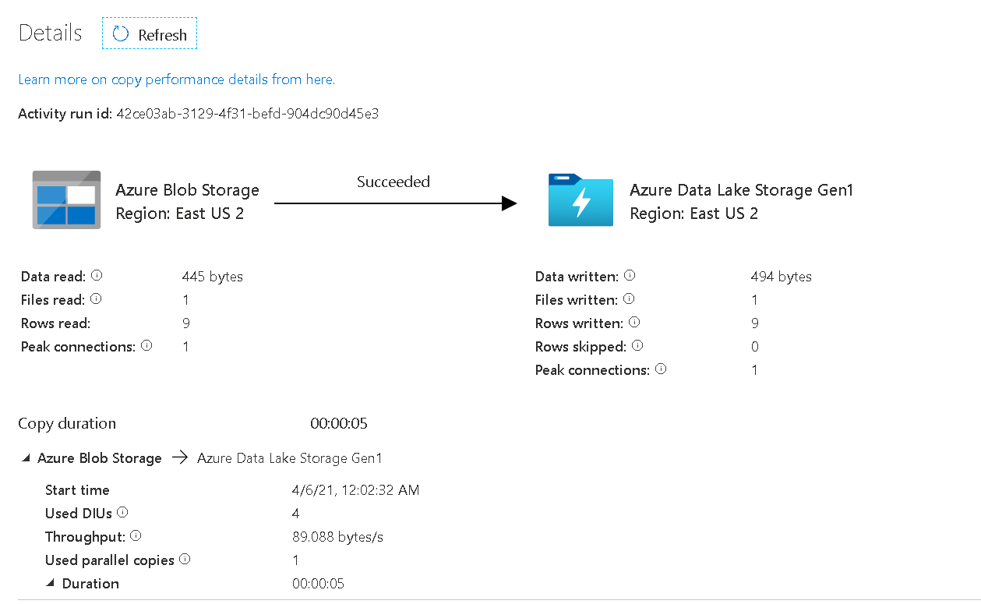

Checking on Azure Portal

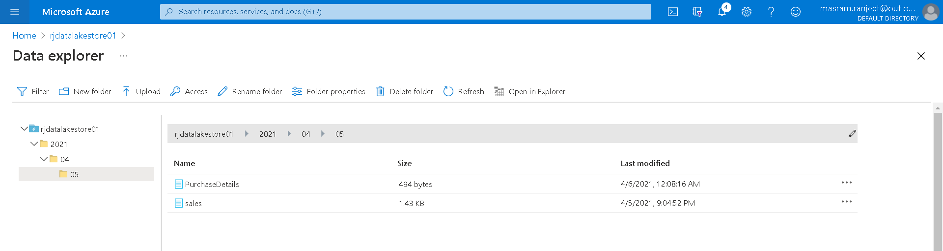

# Transforming Data Using Pipeline

## Union Transformation

In this demo we will retrieve data using Data Flow transformation

Goto **Data Lake store and create a new folder named output**

Goto Azure Data Factory 🡪 Author 🡪 Pipeline

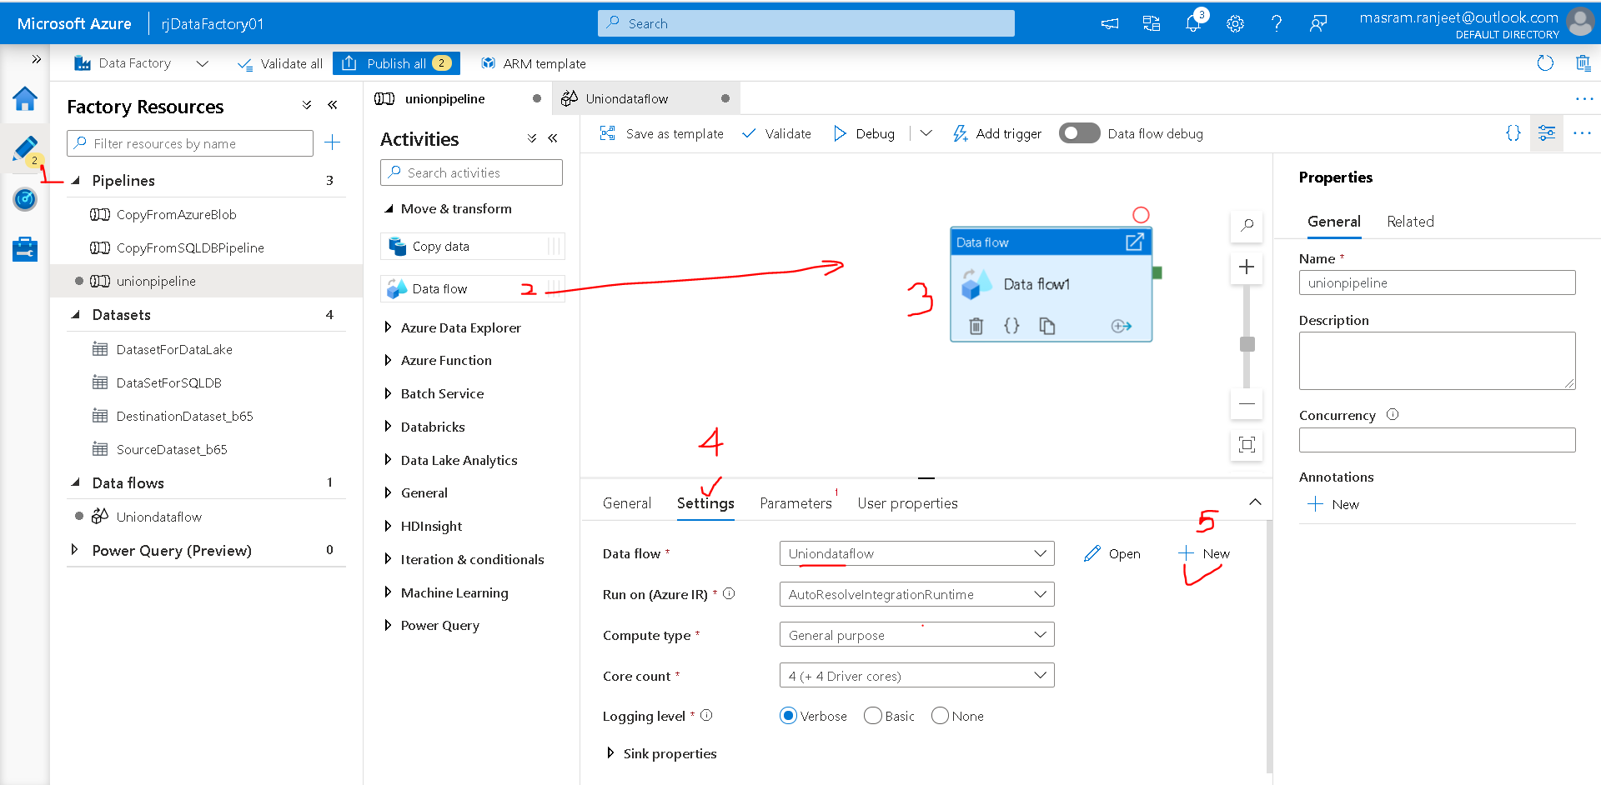

Finish 🡪 Add Source

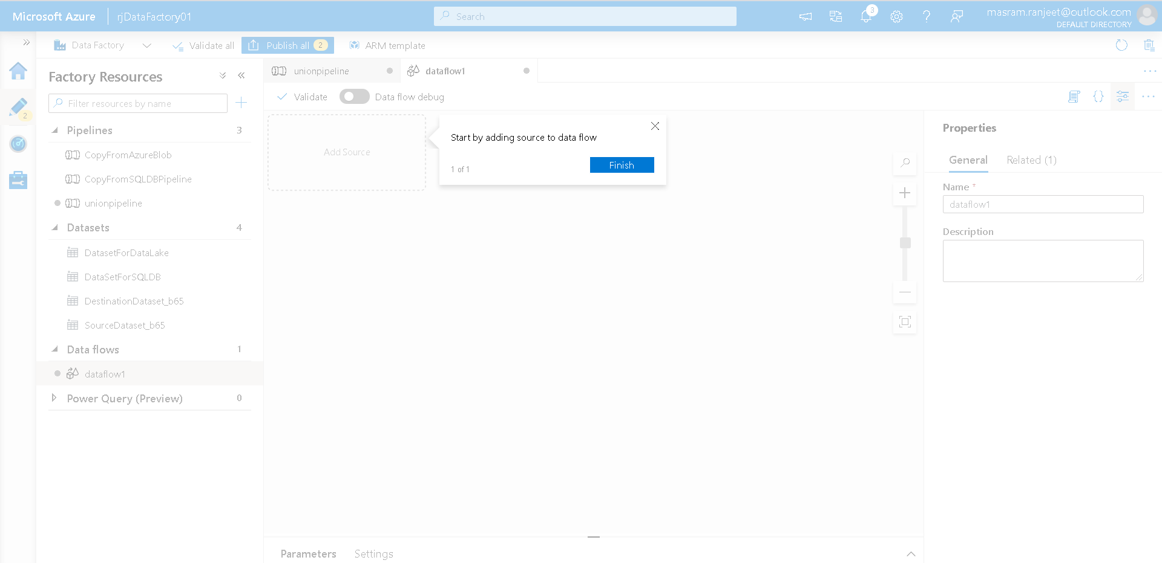

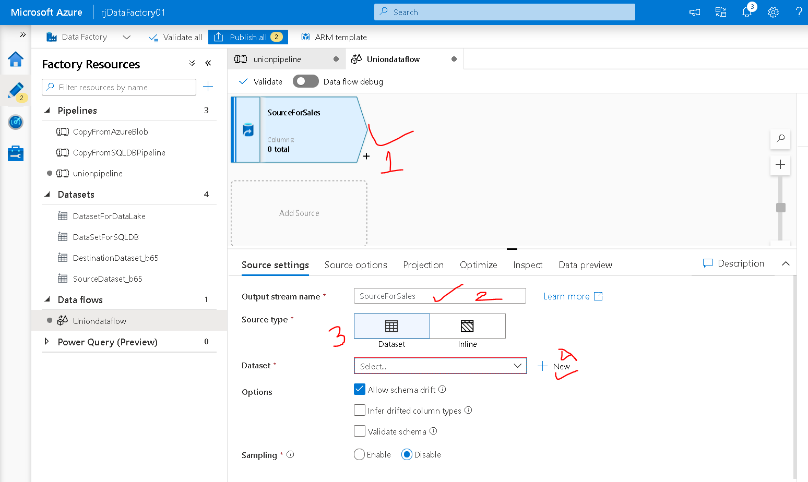

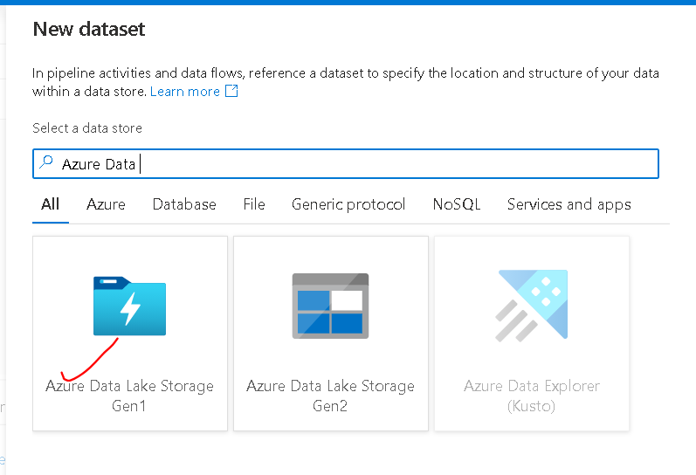

DelimitedText Format

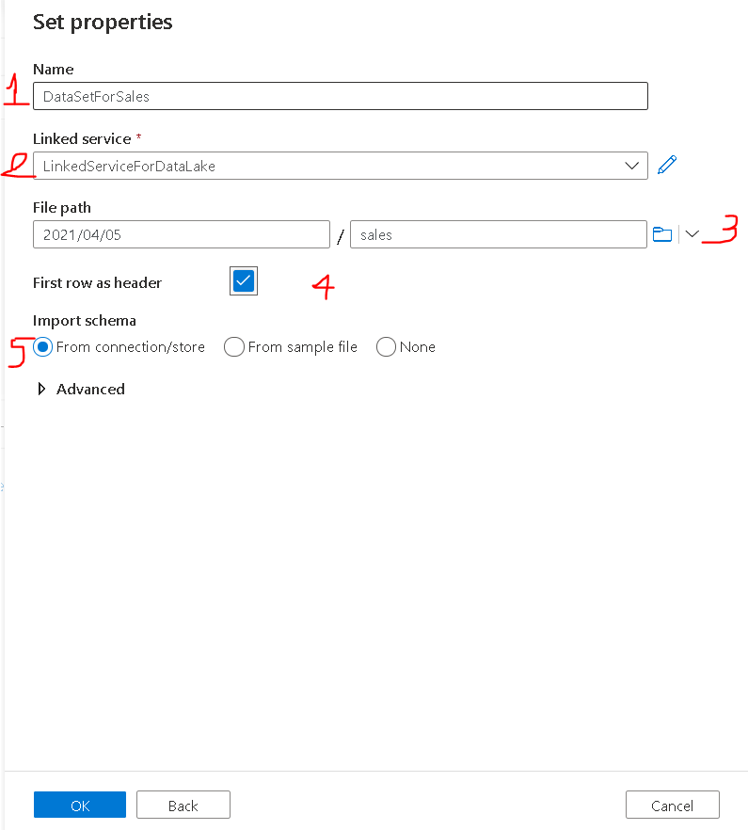

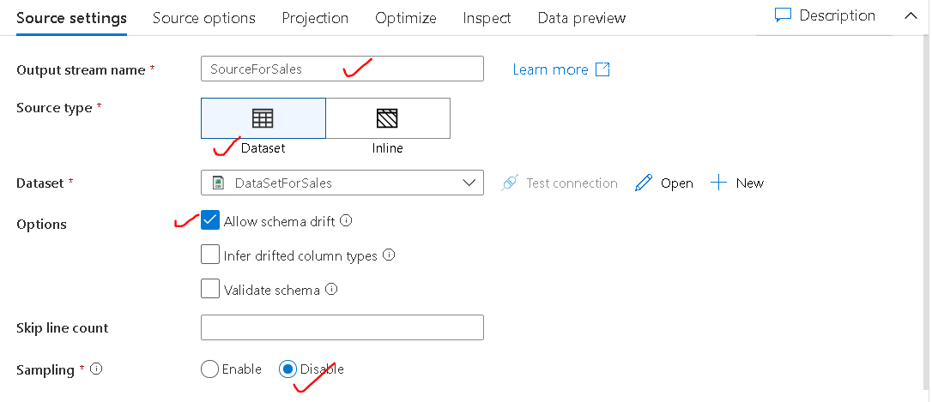

Go on top and set “Data Flow Debug” on to preview the data in “Data preview” tab

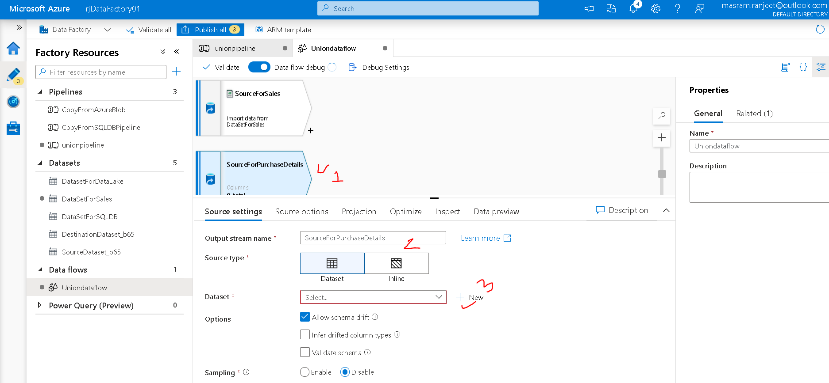

Select Data Lake Storage Gen1 🡪 Delimited Text

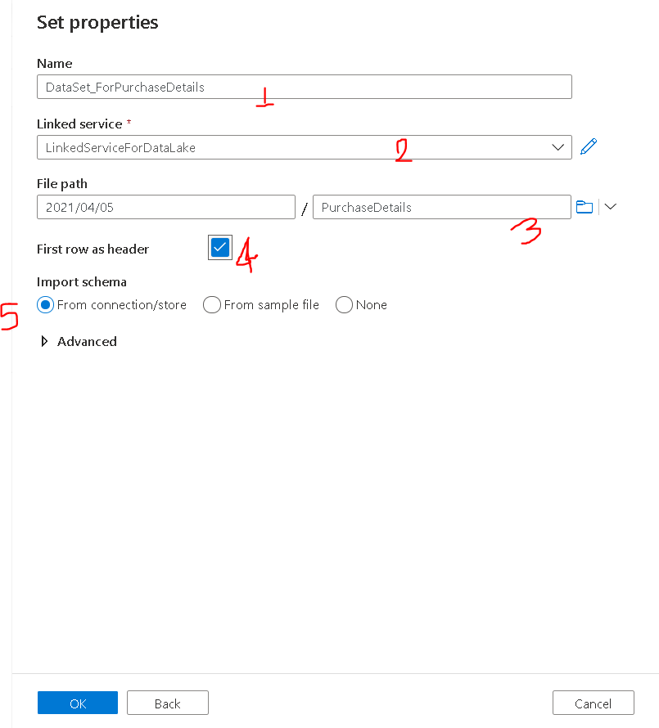

Keeping Default for other settings

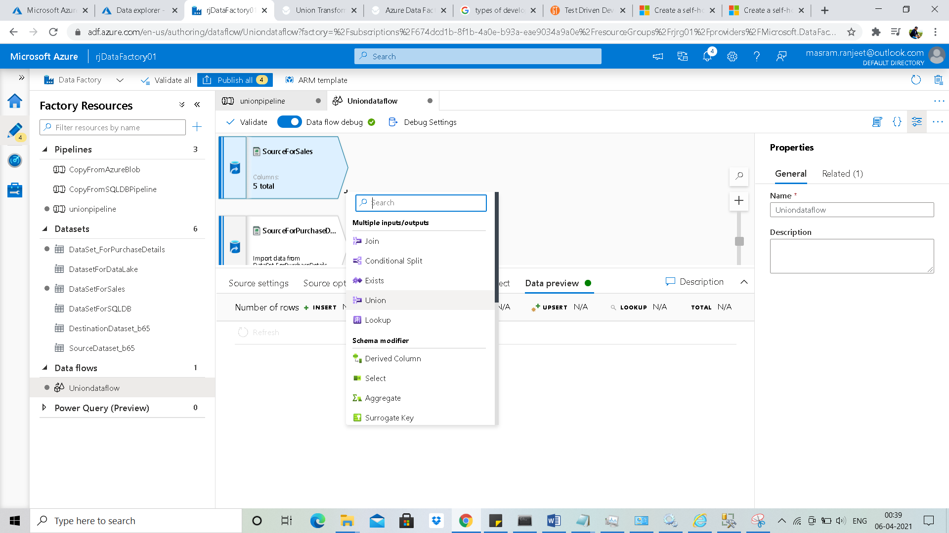

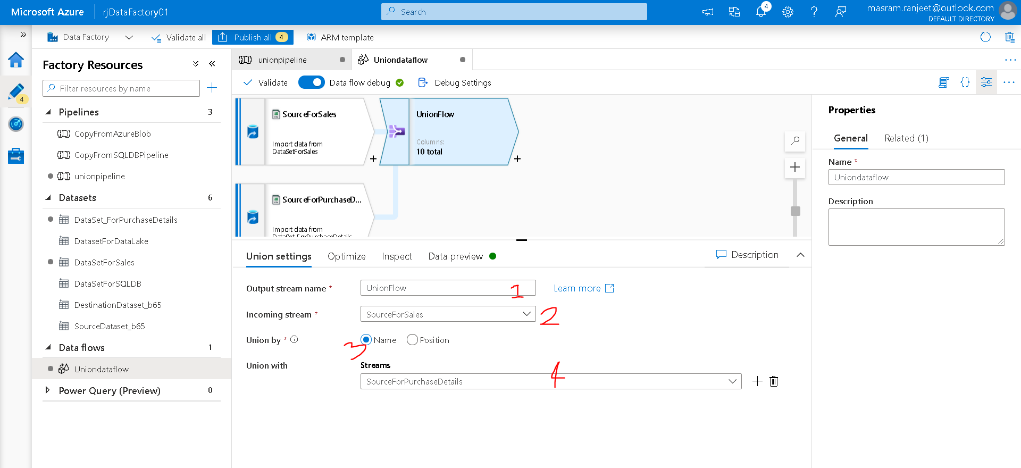

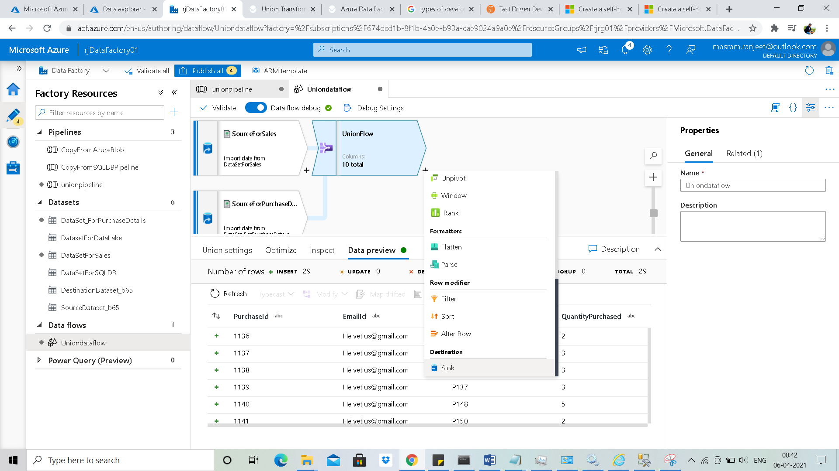

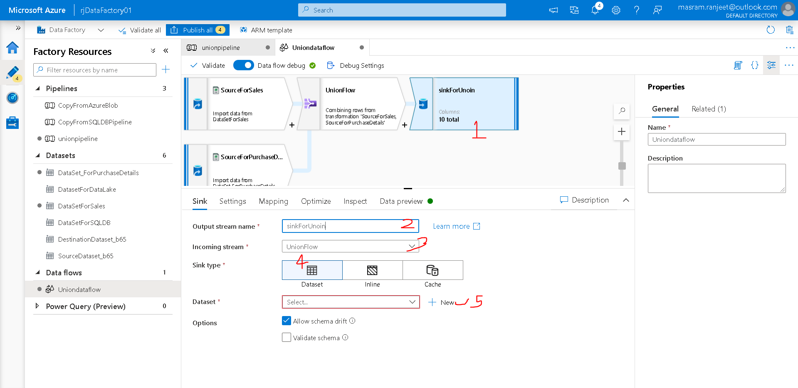

Data Lake Gen1 🡪 DelimitedText

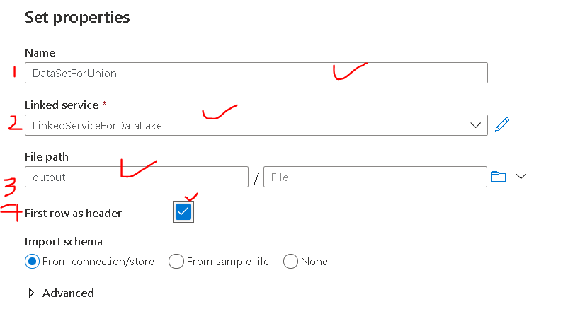

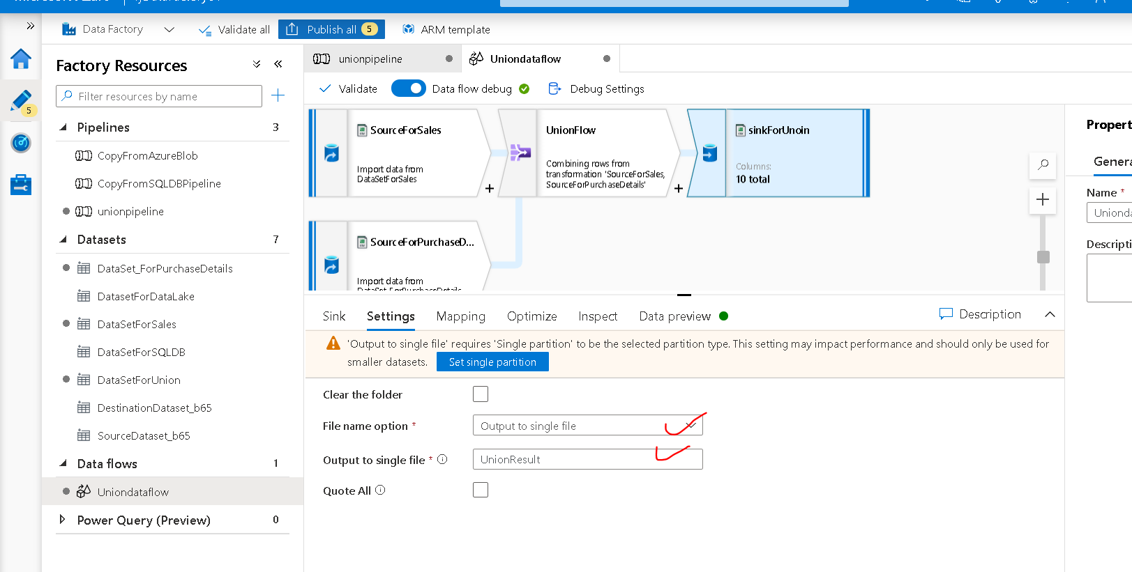

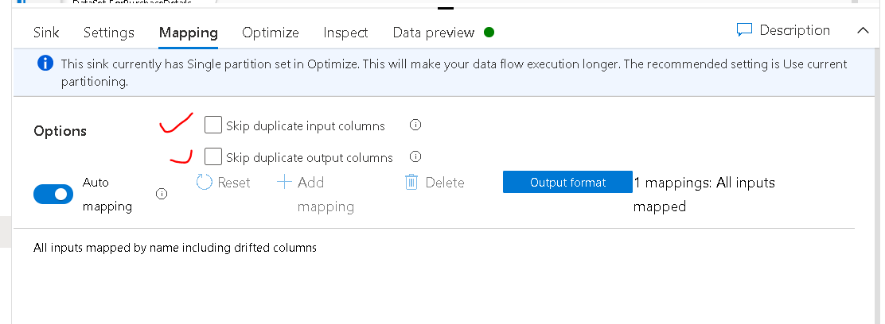

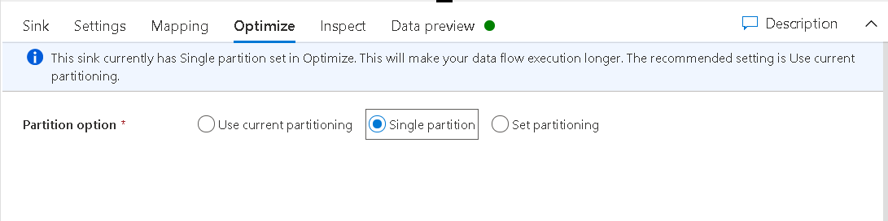

Executing Pipeline

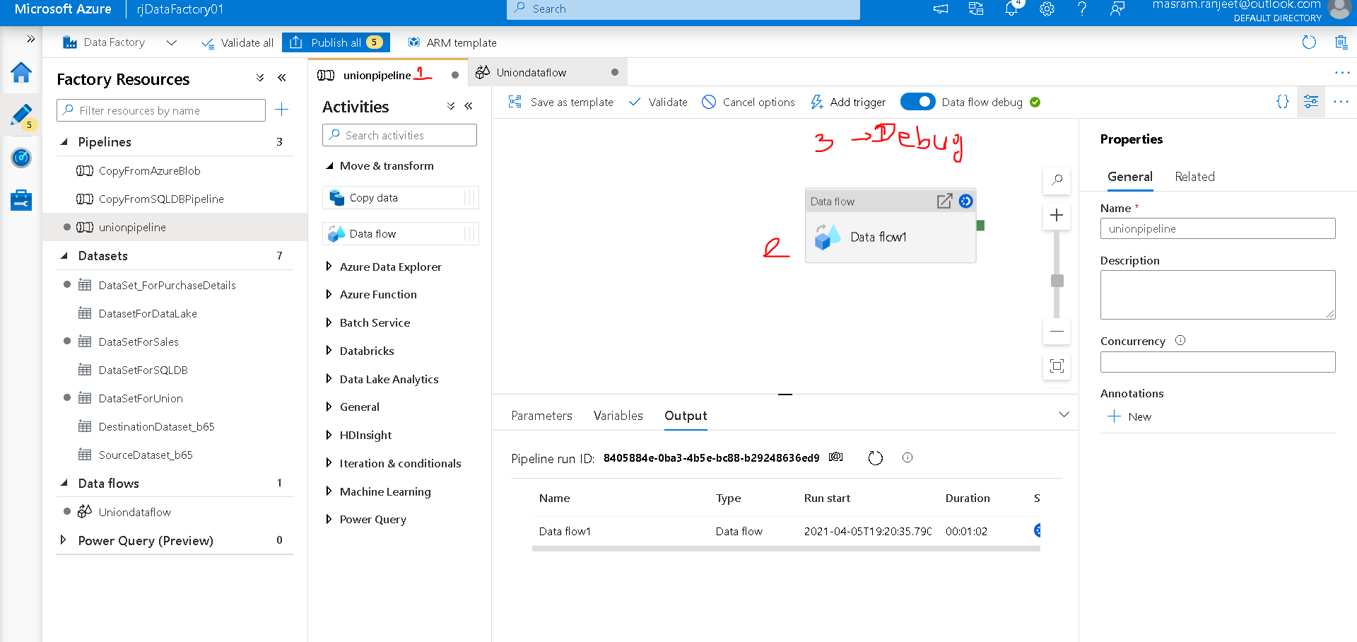

Click on spects symbol

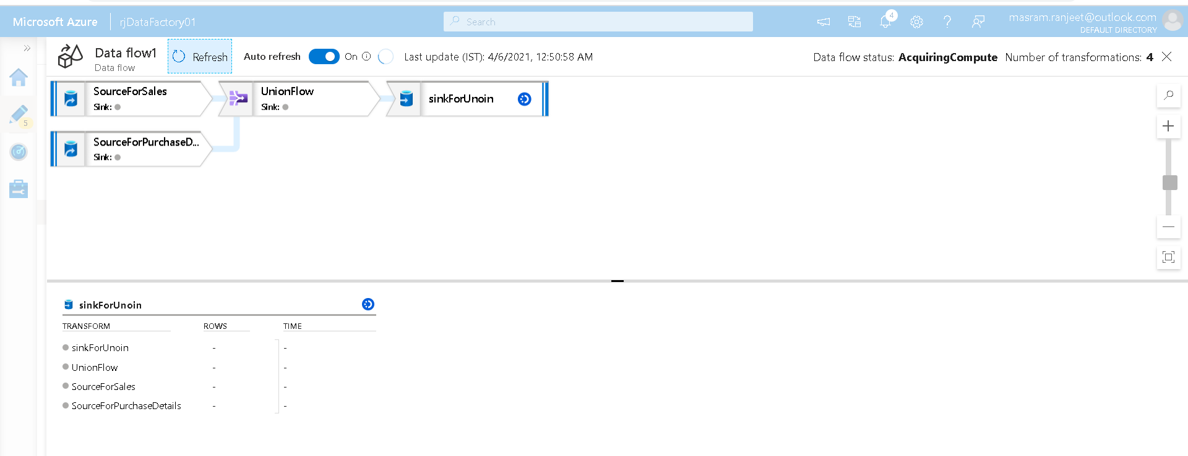

## More Transformation

We are going to perform

* Select
* Aggregate
* Sort

On the output of union transformation

Go to Data Factory UI 🡪 Author 🡪Create new pipeline

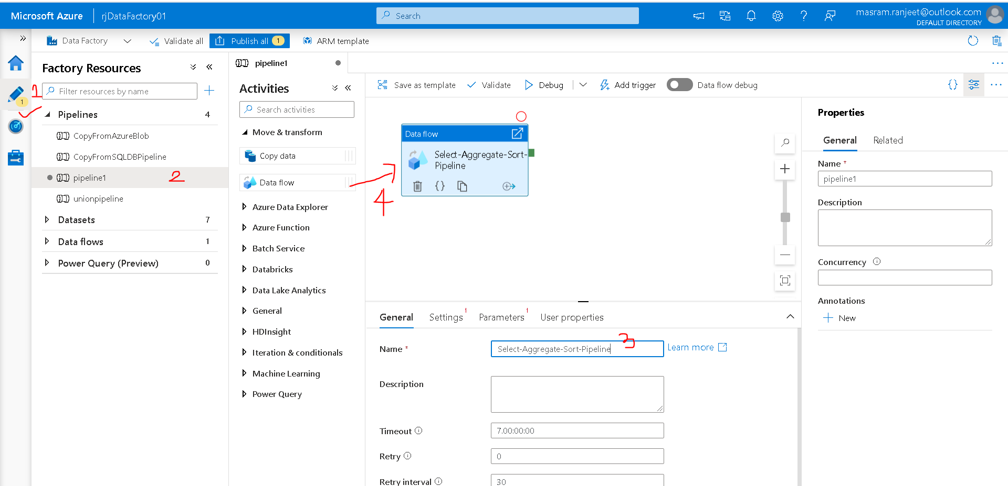

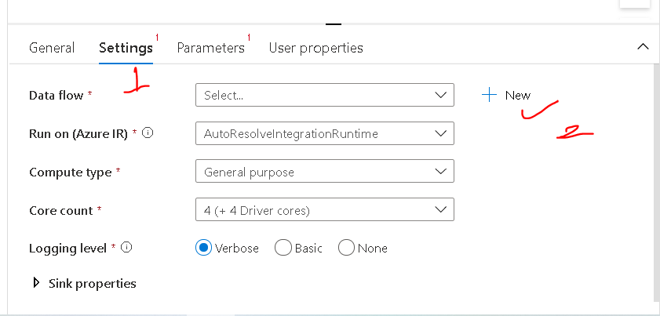

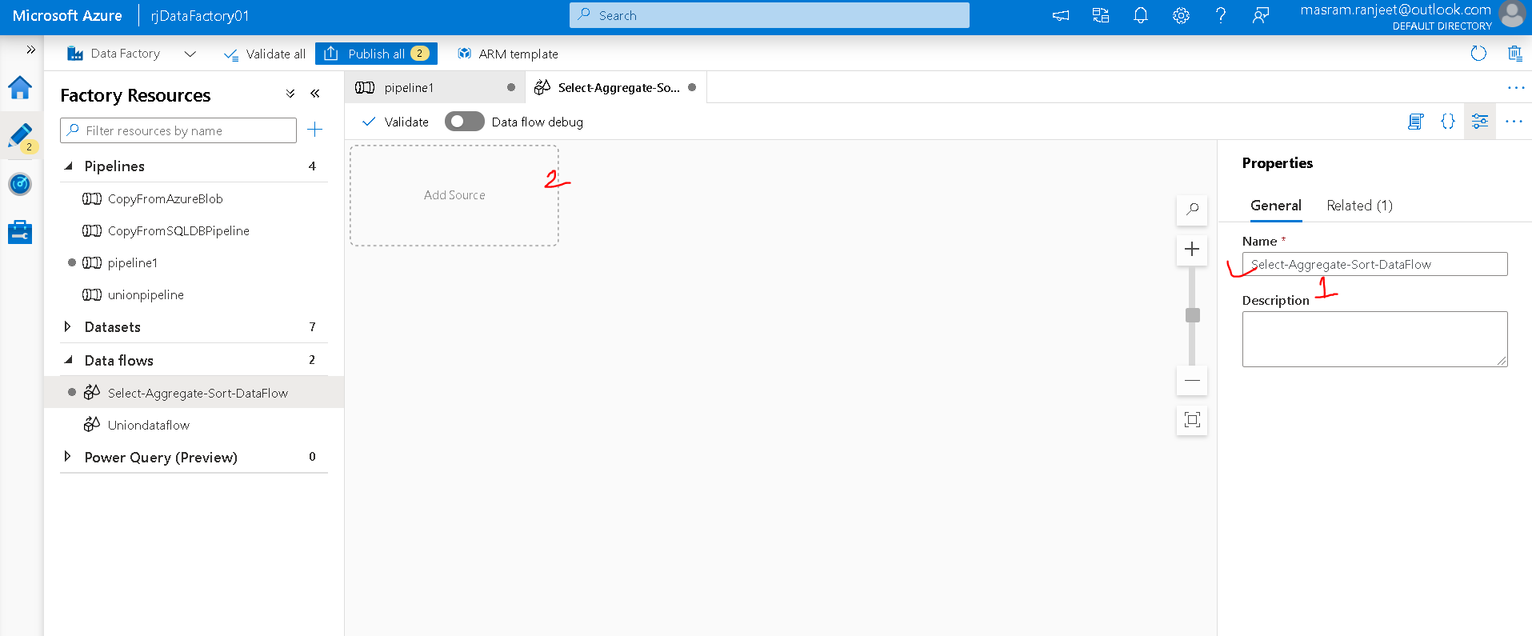

Now we need to add the source and configure the setting for the source

Creating a new Azure DataLake Dataset 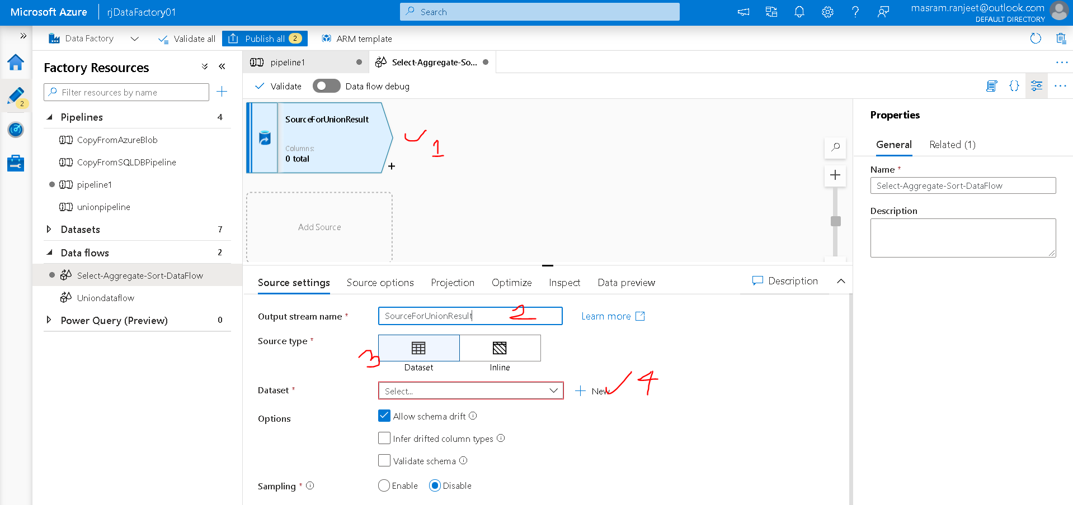

New 🡪 Azure Data Lake Gen1 🡪 Delimited Text

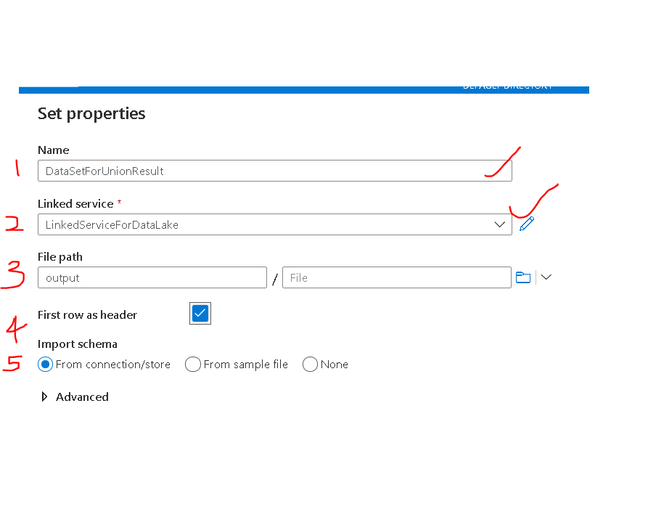

Click Ok.

In Source option tab let us keep the default settings only

Projections - 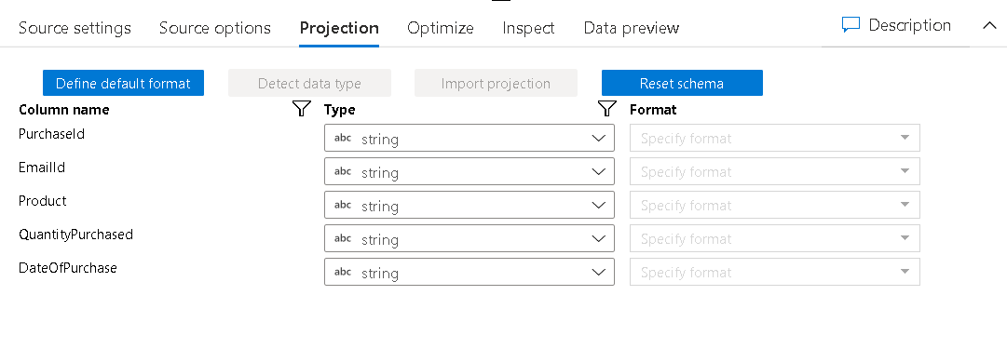

Optimize tab – Single Partition

Turn On **Data Flow Debug on top**

Now we need to perform the **select transformation**

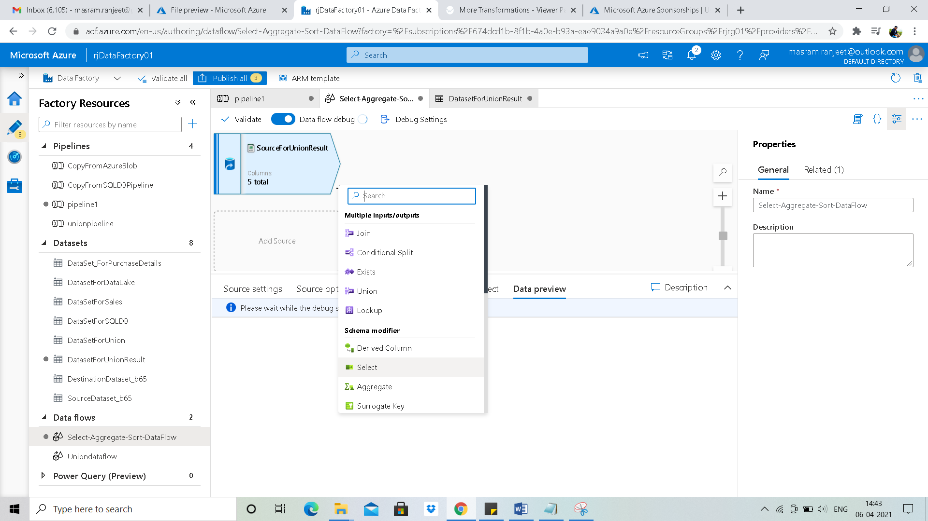

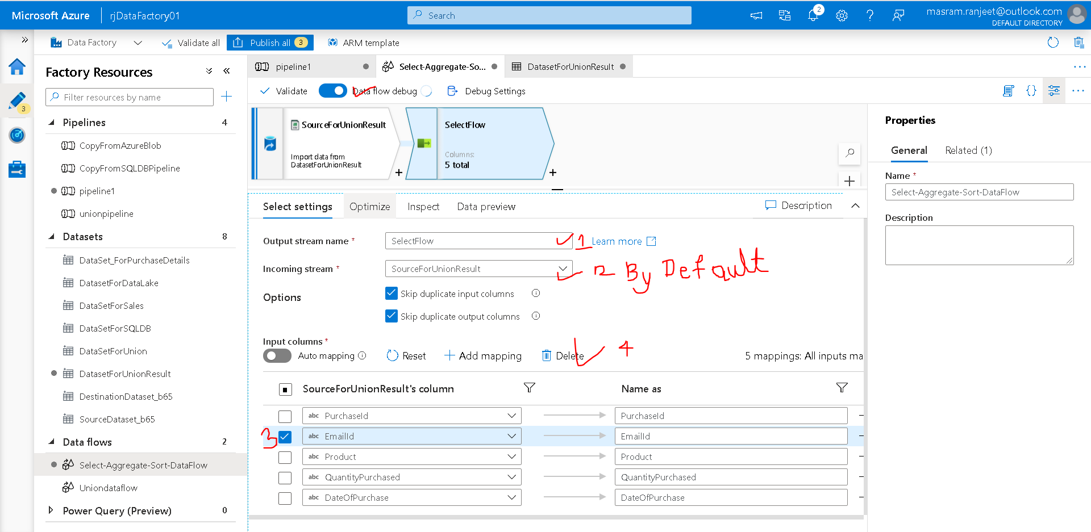

Deleting EmailId Mapping column

Optimize tab – Single Partition

Next we will calculate the count of Quantity Purchased of Product using **Aggregate Transformation**

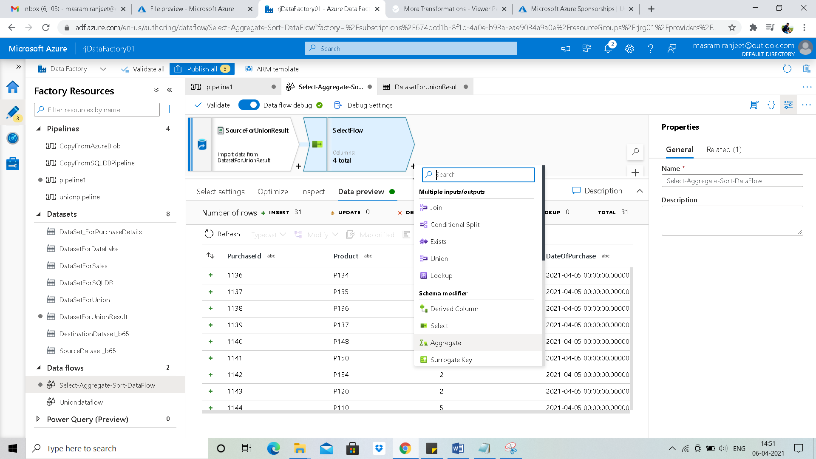

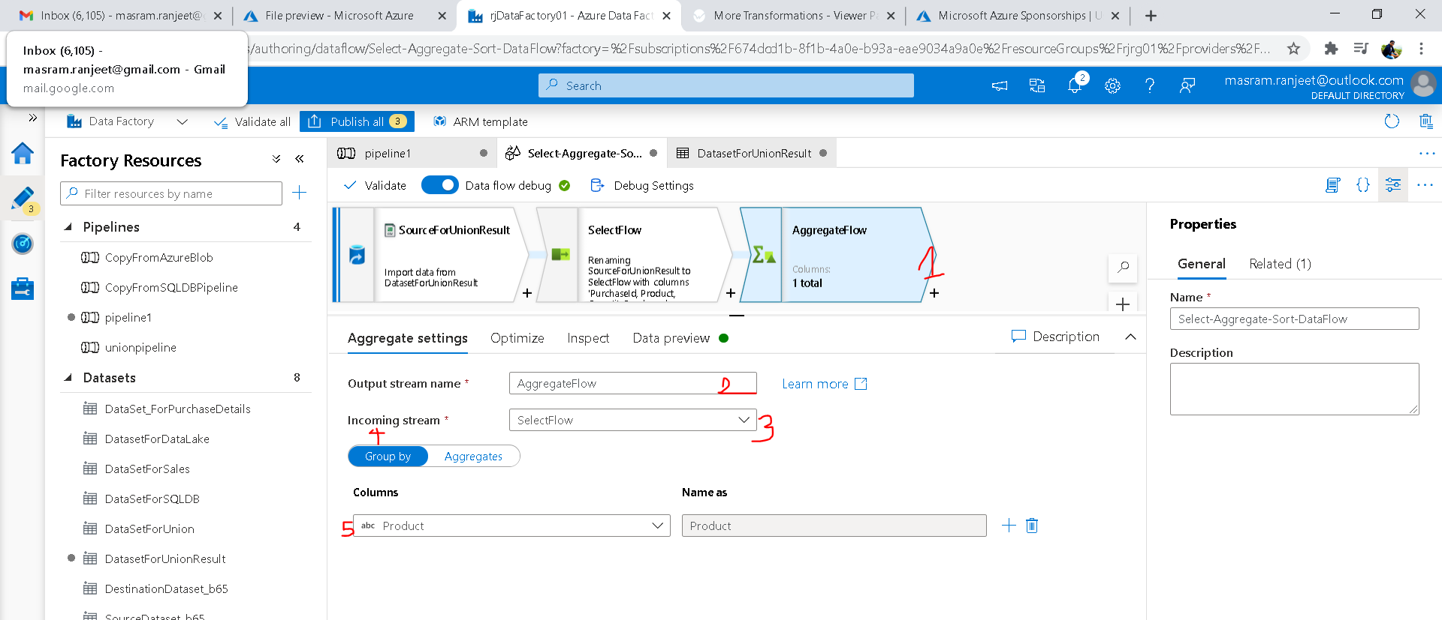

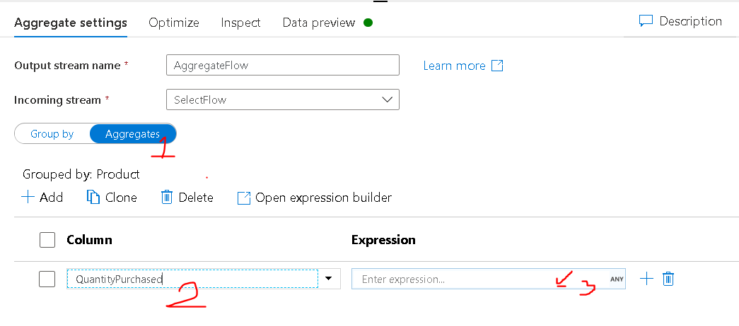

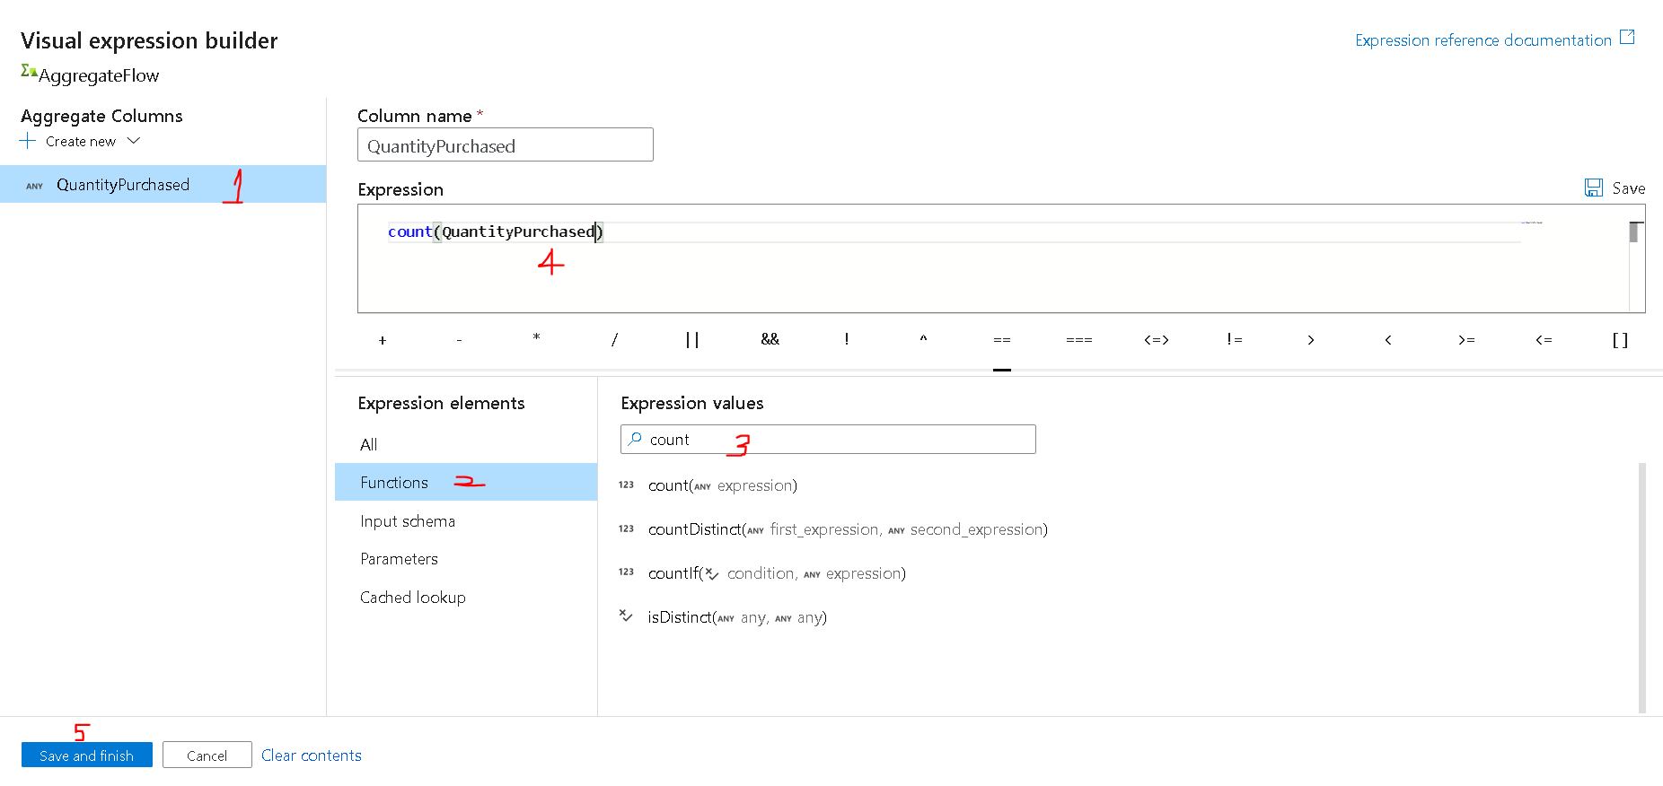

Optimize: Single Partition

Now we will perform **Sort Transformation**

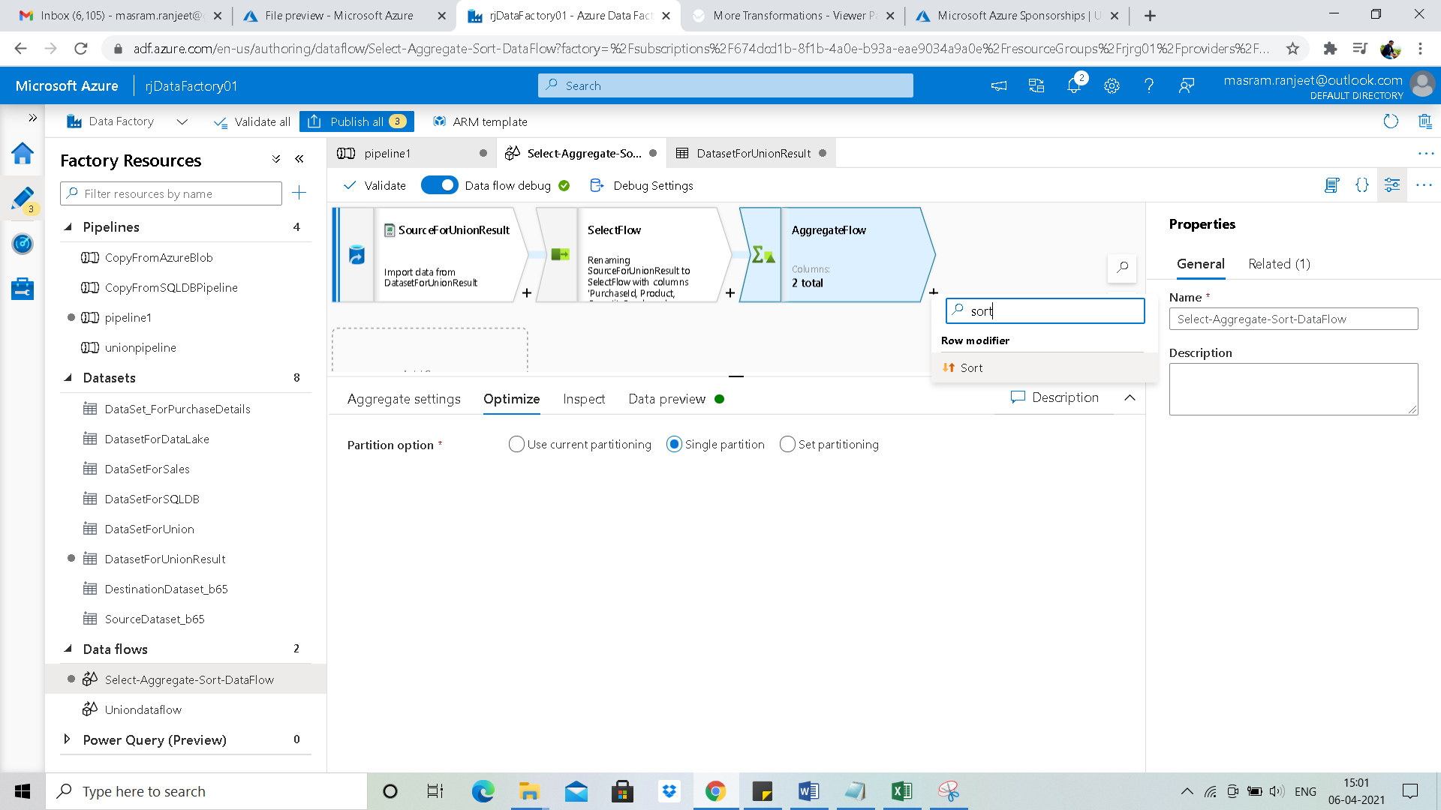

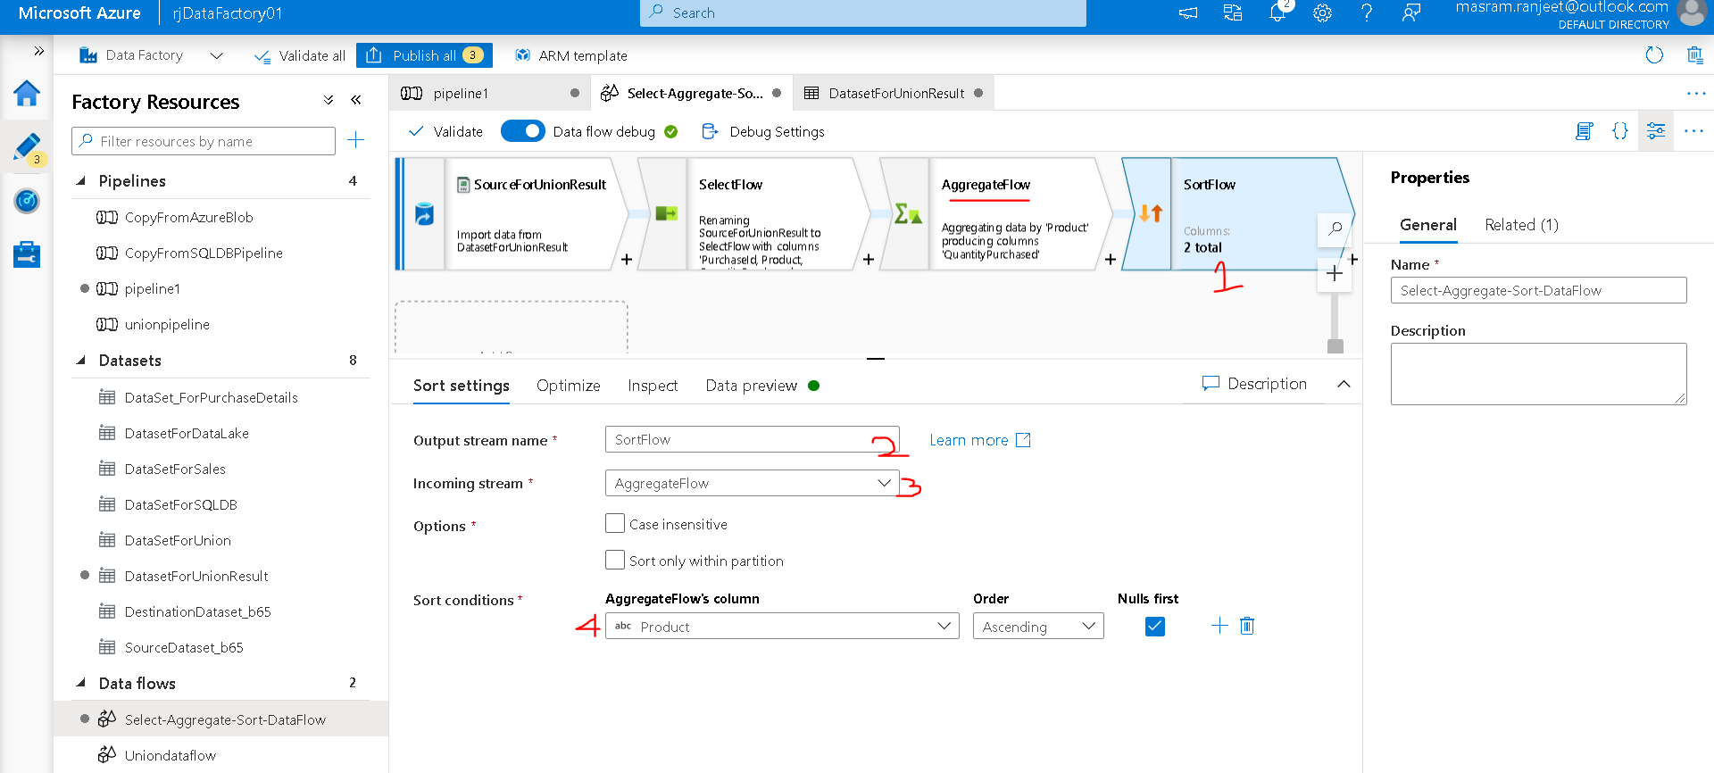

Optimize Tab -> single Partition

Now we need to configure the sink to store the result of sort

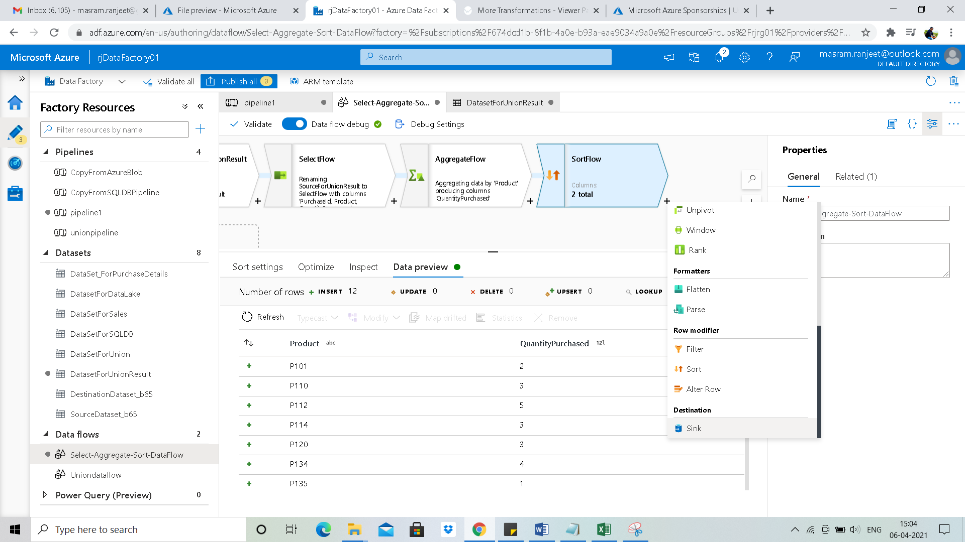

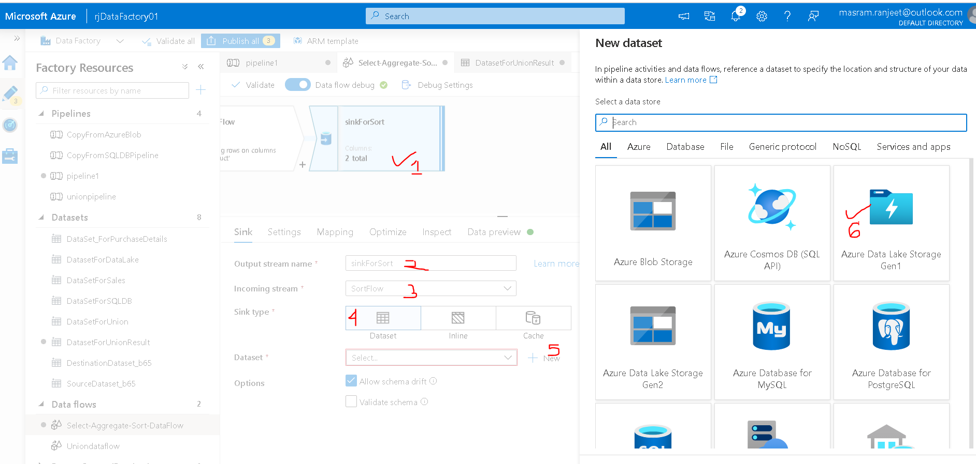

OK🡪DelimitedText

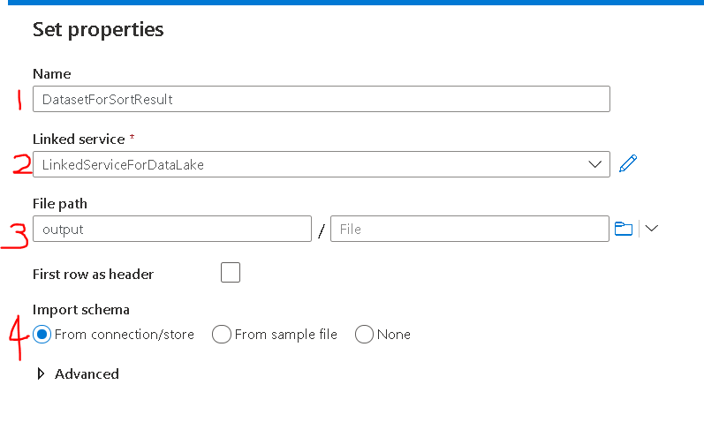

Select First Row as Header

Click on OK

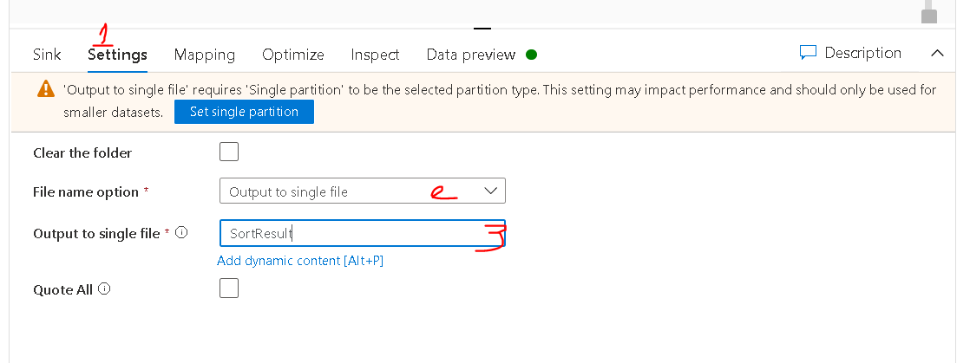

Mapping tab we will keep default settings

Optimize tab 🡪 single partition

To run pipeline select pipeline and Debug

To Save changes click on publish changes

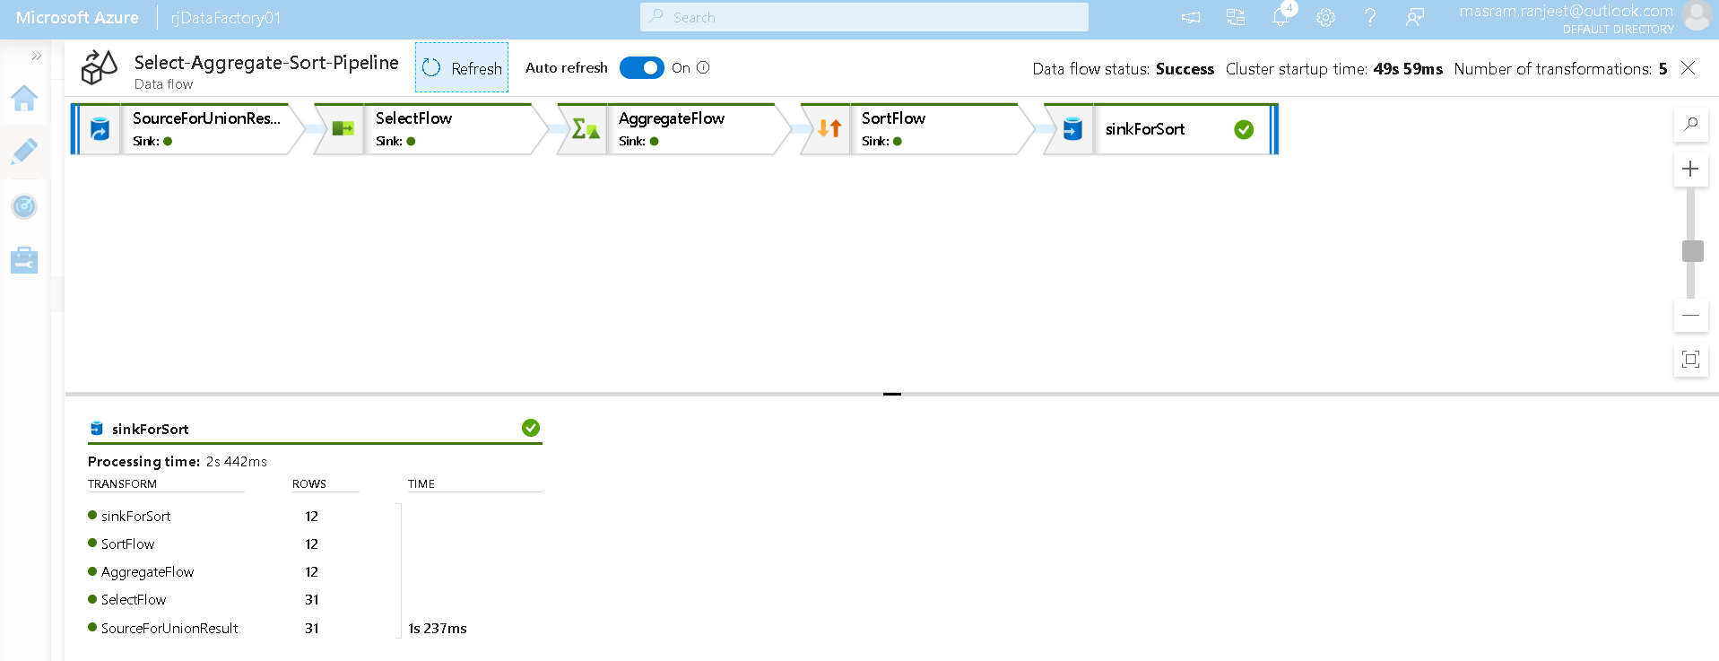

After Running we could see the result in DataLake 🡪 Output Folder 🡪 SortResultFile

# Triggers in Pipeline

Trigger is used to automate the pipeline execution.

## Types of Triggers

Types of Triggers

1. Schedule Trigger
2. Tumbling Window Triger
3. Event-based Trigger
4. **Schedule Trigger**

-Runs pipelines on wall-clock schedule

- Load data only for future date

- Reliability is low

- No Retry capability

- No concurrency support

**b) Tumbling Window Triger**

- Fixed-sized, non-overlapping, and contiguous time intervals

- Load data for past and future date

- Reliability is high

- Retry capability

- Concurrency support

**c) Event-based Trigger**

Runs pipeline in response to event such as

- Arrival of a file in Azure Blob Storage

- Deletion of a file in Azure Blob Storage

## Schedule Trigger

We will create a trigger for Select-Aggregate-Sort-Pipeline

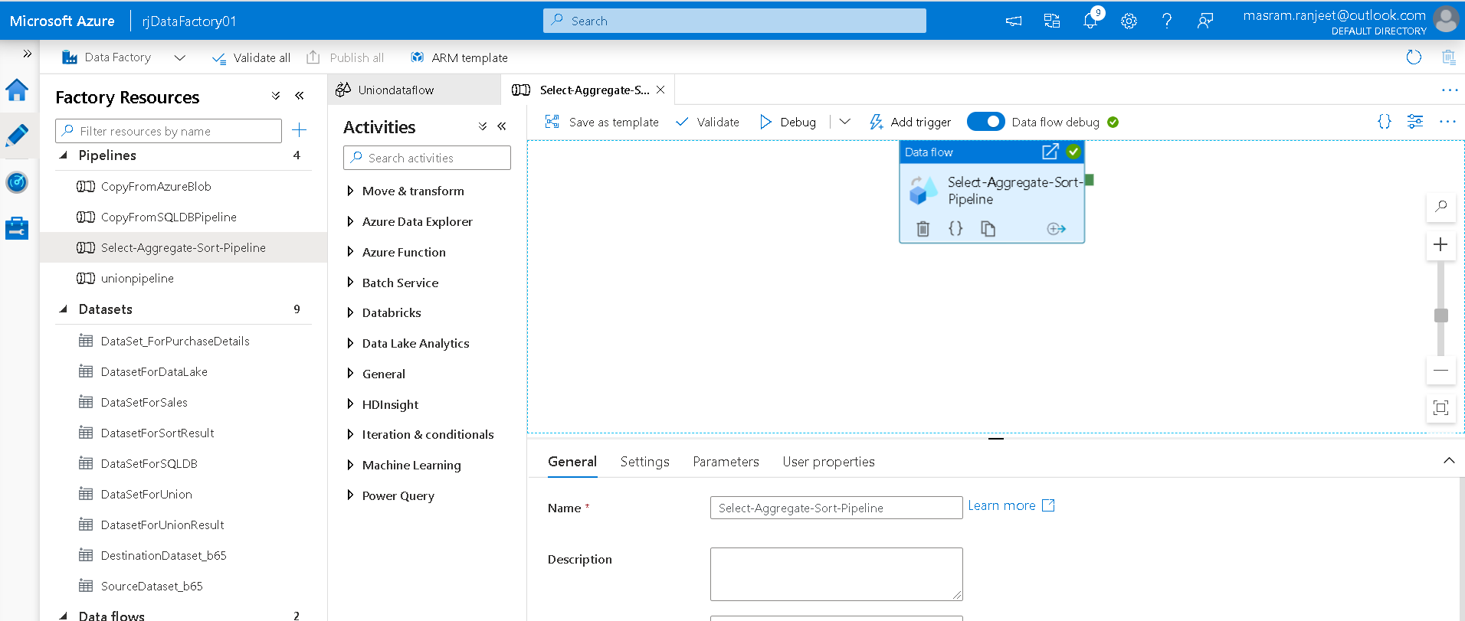

Before we schedule a trigger lets create a parameter in above pipeline to store the start time of the trigger

Click outside Data flow 🡪 Go to parameters tab

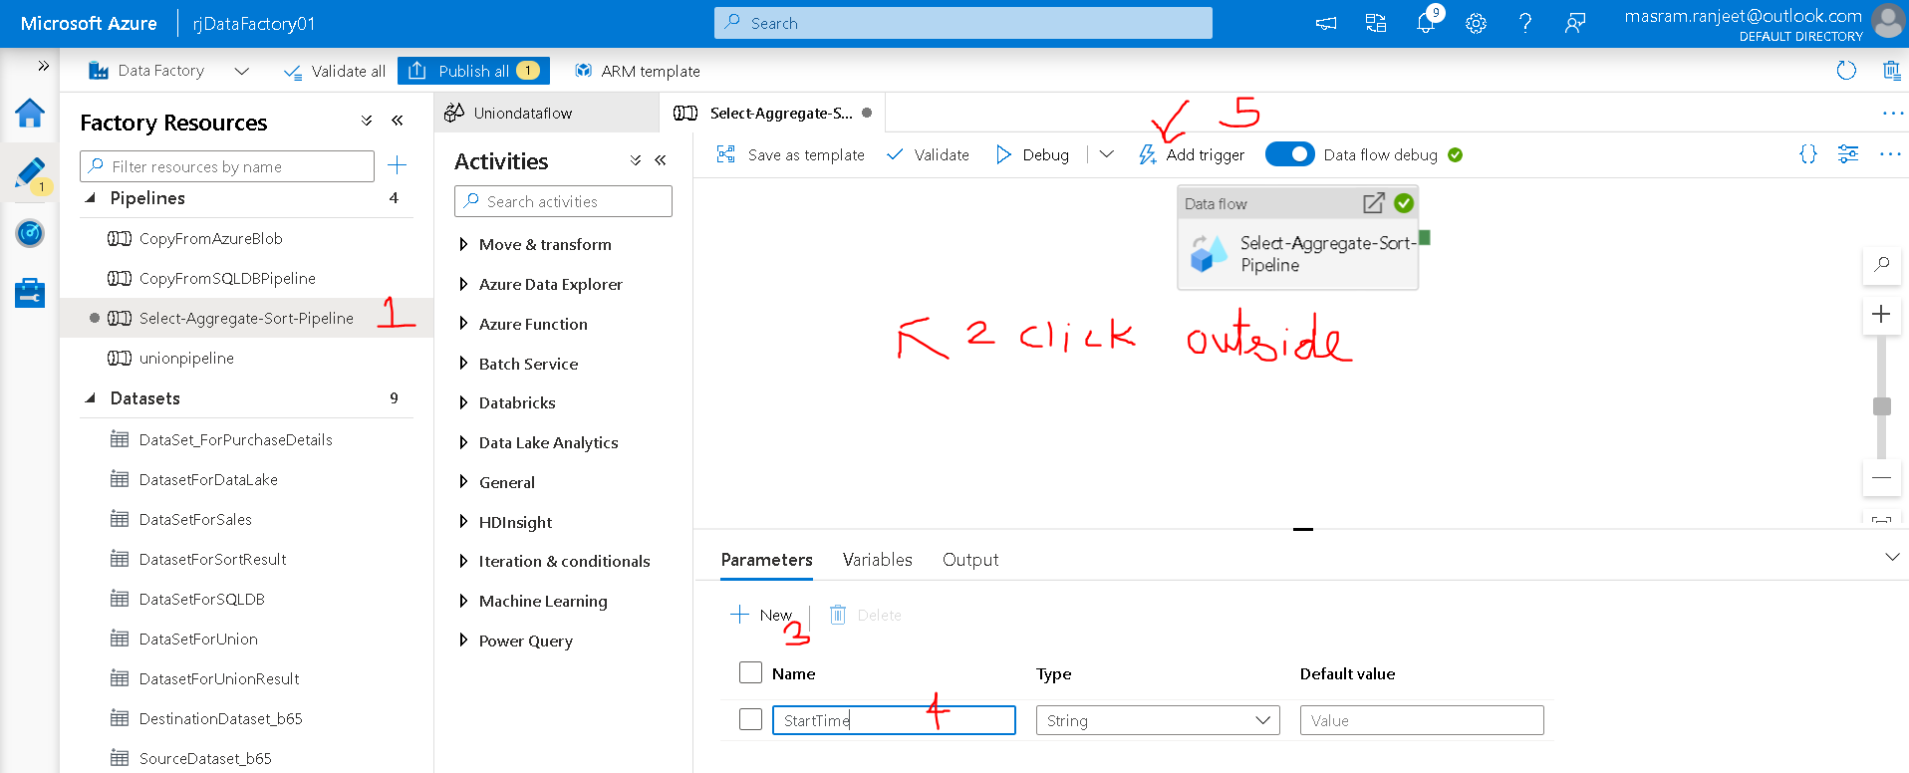

Add Trigger 🡪 New/Edit

Create new trigger

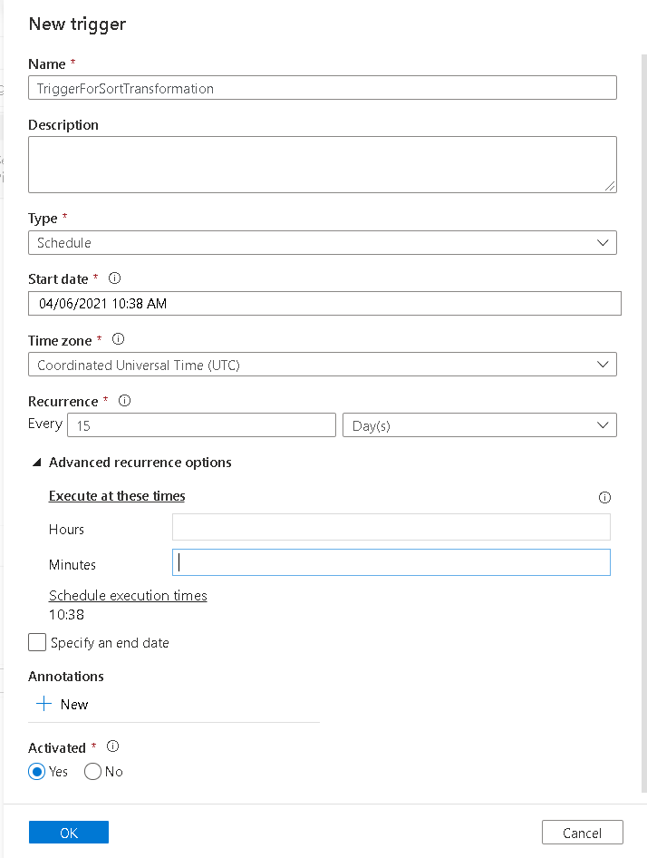

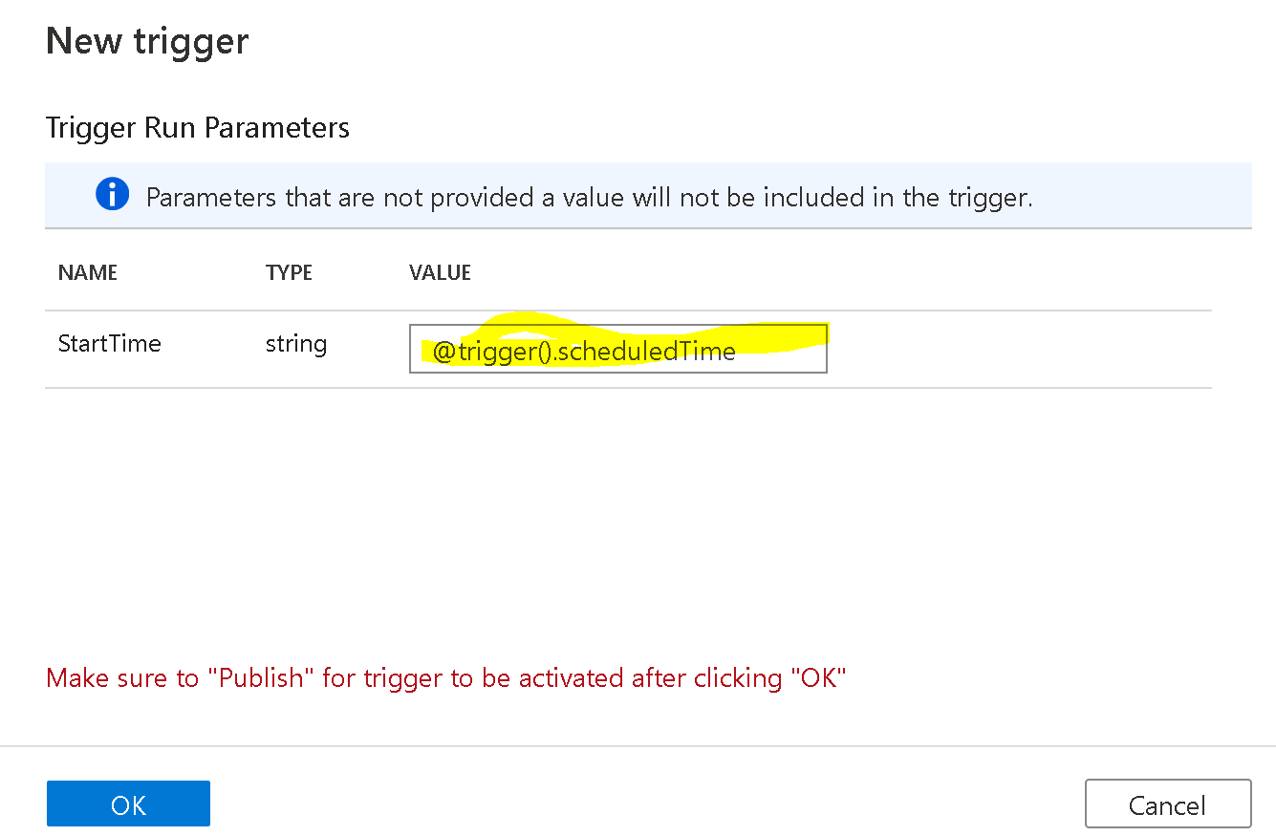

Click Ok 🡪 Publish all changes

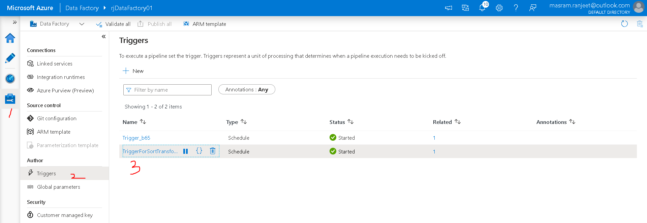

Click on Monitor Icon to check the details of Pipeline and its trigger

